Table of Contents

1.0 Introduction 3

1.1 Objectives 3

1.2 Assumptions 3

2.0 Diagrams 6

2.1 Use Case Diagram 6

2.2 Class Diagram 12

2.3 Activity Diagram 13

2.3.1 Admin 13

2.3.2 Lecturer 16

2.3.3 Student 17

3.0 Object Oriented Programming Concepts 18

3.1 Package 18

3.2 Import 18

3.3 Class 19

3.4 Object 20

3.5 Encapsulation 20

3.6 Constructor 21

3.7 Exception Handling 22

3.8 FileReader 23

3.9 FileWriter 24

3.10 Inheritance 25

4.0 Additional Features 26

4.1 JTable 26

4.2 Array 27

4.3 Password Field 28

4.4 Regex Pattern Validation 29

4.5 SimpleDateFormat 30

5.0 Sample Output 31

5.1 Startup Form 31

5.2 Login Form 32

5.3 Main Menu Form 33

5.4 Registration Form 35

5.5 View Records Form 38

5.6 Edit Details Form 39

5.7 Delete User Form 41

5.8 Inbox Form 42

5.9 View Intakewise Students Form 43

5.10 Contact Admin Form 44

5.11 Mark Attendance 45

5.12 Modify Attendance 47

6.0 Conclusion 49

7.0 References 50

# 1.0 Introduction

This document is about Attendance Management System built for XYZ University to be used by students and faculty. The system is to be developed using object-oriented programming in Java language. The three types of users of this system are Admin, Lecturers, and Students who have to login into the system using their user ID and password. The objectives of the system as defined by the customer are as follows.

## 1.1 Objectives

Admin must be able to register lecturers and students as new users, search for a specific lecturer or student, delete the record of lecturer or student, view all lecturers and students, edit their details and delete their record. Admin can also modify the attendance of student by changing ABSENT to ABSENT WITH REASON as per student’s reasonable request.

Moreover, Lecturers should be able to view the intakewise students as assigned to them by Admin, mark attendance for each class by providing class specifics such as lecture date, start and end times, module name, and intake code. Lecturers may only mark the attendance record as PRESENT, ABSENT, or LATE and they are allowed to modify the attendance after submitting it.

Finally, with this system Students can view their attendance summary. If Student would like to update their attendance, they are able to send a message to admin containing the reason why they were absent so that Admin would change their attendance record from ABSENT to ABSENT WITH REASON.

## 1.2 Assumptions

All functional requirements as requested by the customers will be fulfilled. This system should begin with a startup form where user must choose which type of user they are (Admin/Lecturer/Student) and it will bring them to an appropriate login form depending on their user type. Once logged in using their user ID and password, a main menu for the appropriate user type will appear containing links to forms that allow user to perform the functionalities as assigned to them. Validations exist in the registration form, edit details form, and every other form that contains a search bar. This means if there are any unfulfilled requirements then the system will show an error message. Otherwise, if everything seems acceptable, the system will issue a dialog box to indicate success of performing the function.

When registering a new user, Admin has to fill in the user details in all the required fields and must make sure that the data entered are in the correct format, otherwise an error message will show up. Admin must assign 2 intakes and 2 modules for each lecturer, and those 2 intakes must be different from one another, so do the 2 modules. When assigning user ID and password for the new user, Admin must retype the password in another field and those 2 password fields have to match before the user is created.

When editing the details of a user, first Admin has to search for the user by entering their user ID in the search bar. If the user exists, the details of the user will be displayed in the appropriate fields which are editable. If the user does not exist, an error message will show up to indicate Admin to enter a valid user ID. There is validation in the contact number field to ensure that the data entered is in integer only, and the email address field to ensure that data entered is in a valid email format. Once user clicks the “Update” button to save the information, a confirmation message will pop up in which user has to click the Yes option in order for the data to be updated in the system. The delete user form uses the same concept, except the text fields are non-editable.

Admin can also view records of lecturers or students inside a table. They can also search for a specific user using the search bar, however the details displayed in the text fields are not editable as this form is for viewing only.

To view messages sent by students, Admin can check their inbox which will load one message per form, thus to go to the next message Admin has to click the “Next Message” button. After reading the reasons of absenteeism sent by students, Admin can modify their attendance after picking the related class in the modify attendance form. However, Admin can only change the student’s attendance from Absent to ABSENT WITH REASON.

Meanwhile, for lecturers to view the intakewise students assigned to them, they have to first choose one out of the two intakes in which they are in charge of from the combo box. The module field will be set automatically based on the intake chosen. The student records will be shown in a table after user clicks the “Get List” button.

To mark attendance, lecturer has to enter the class details such as intake code and the time period from the combo box. The date is set automatically to today’s date, because lecturers take attendance near the end of a lecture class. The module is also set automatically depending on the intake chosen. Afterwards, the system will show the list of students for that particular class inside the table, then the lecturer can mark them as PRESENT, LATE, or ABSENT. Whereas to modify the attendance, lecturer has to pick a previous class first and then modify the attendance to either PRESENT, LATE, or ABSENT and save it.

As for Students, they are able to view their attendance summary, and if they are unsatisfied with it, they can send a message to Admin stating the reason why they were absent for a particular class, so that Admin would change their attendance.

# 2.0 Diagrams

## 2.1 Use Case Diagram

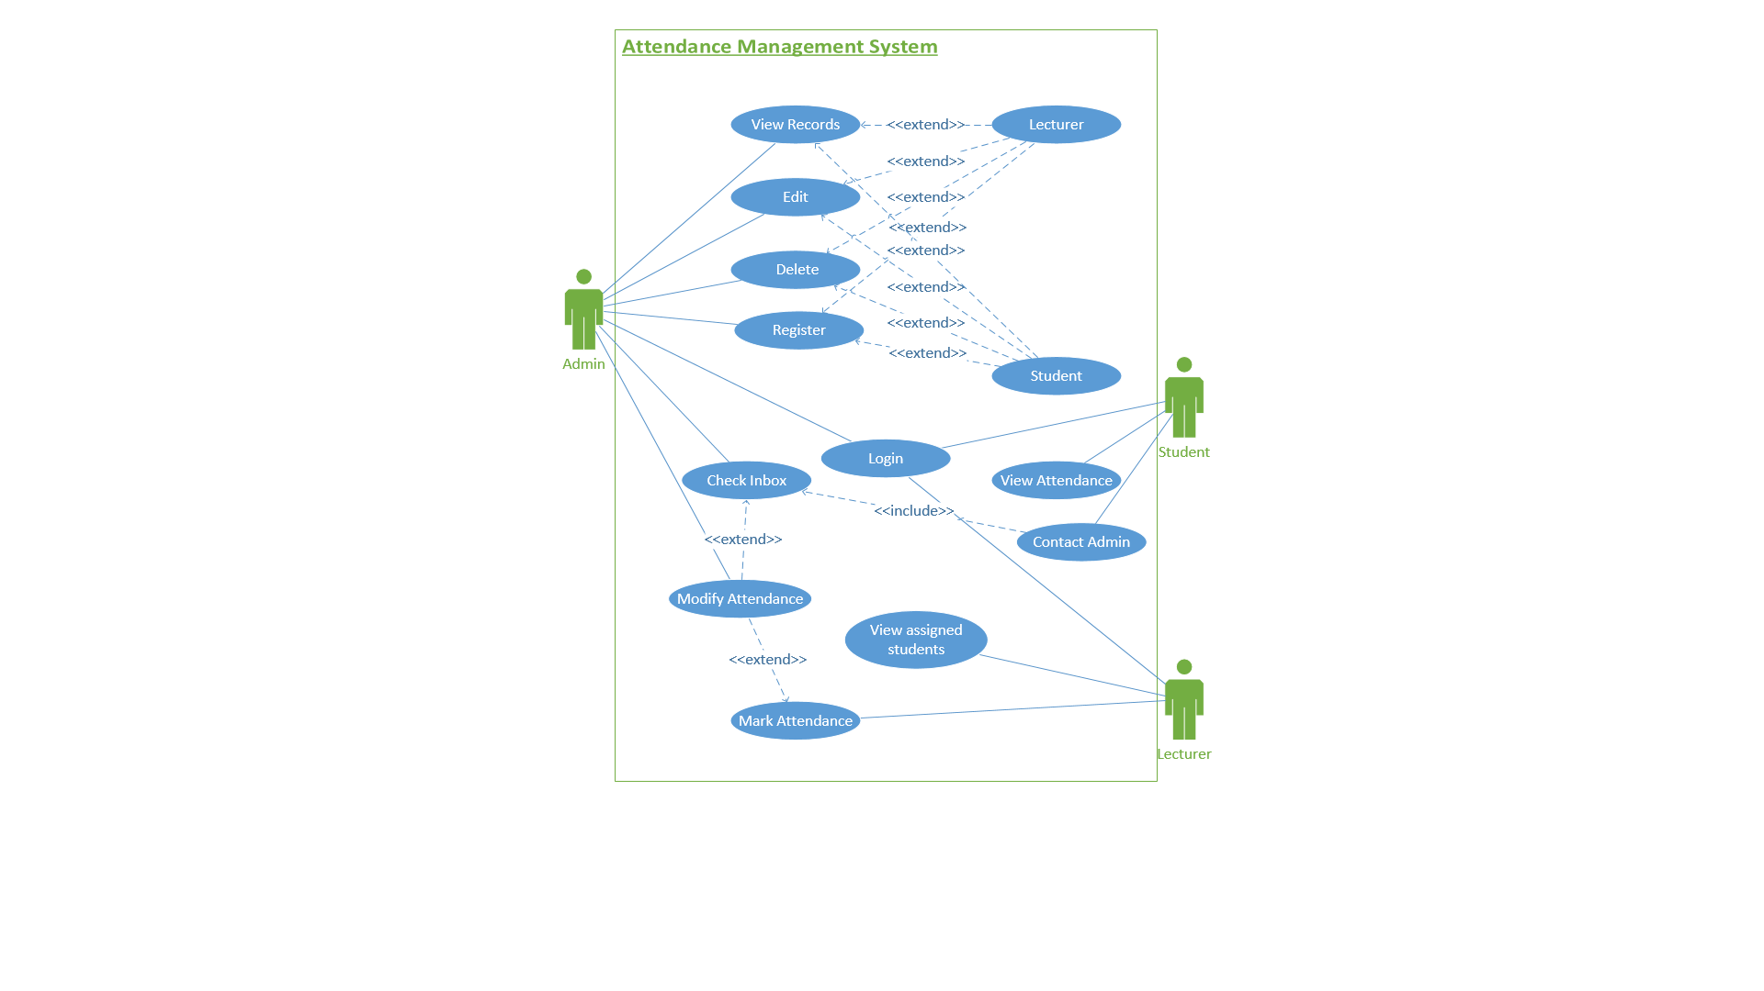

*Figure 2.1: Use Case Diagram*

|  |  |
| --- | --- |
| Name | View Records |
| ID | N/A |
| Description | User can view a table containing details of all lecturers/students. User can also search for a particular lecturer/student based on their user ID and be shown the details of that particular account only. |
| Actor(s) | Admin |
| Organizational Benefits | N/A |
| Frequency of Use | N/A |
| Triggers | Admin clicks “View Records” button from Main Menu. |
| Precondition | Logged in as Admin |
| Post-condition | N/A |

|  |  |
| --- | --- |
| Name | Edit |
| ID | N/A |
| Description | User can search for a lecturer/student and then edit or update their details |
| Actor(s) | Admin |
| Organizational Benefits | N/A |
| Frequency of Use | N/A |
| Triggers | Admin clicks “Edit Details” button from Main Menu |
| Precondition | Logged in as Admin |
| Post-condition | The lecturer/student record in the text file is updated |

|  |  |
| --- | --- |
| Name | Delete |
| ID | N/A |
| Description | User can search for a lecturer/student and then delete their account |
| Actor(s) | Admin |
| Organizational Benefits | N/A |
| Frequency of Use | N/A |
| Triggers | Admin clicks “Delete User” button from Main Menu |
| Precondition | Logged in as Admin |
| Post-condition | The lecturer/student record in the text file is deleted |

|  |  |
| --- | --- |
| Name | Register |
| ID | N/A |
| Description | User can register new lecturer/student by inserting the necessary details |
| Actor(s) | Admin |
| Organizational Benefits | N/A |
| Frequency of Use | N/A |
| Triggers | Admin clicks the “Register” button from Main Menu |
| Precondition | Logged in as Admin |
| Post-condition | There will be a new record containing the inserted details of that new lecturer/student in the respective text file |

|  |  |
| --- | --- |
| Name | Lecturer |
| ID | N/A |
| Description | User can perform actions concerning lecturers. It is an extension of View Records, Edit, Delete, and Register use cases. |
| Actor(s) | Admin |
| Organizational Benefits | N/A |
| Frequency of Use | N/A |
| Triggers | Admin clicks the relevant buttons concerning students from Main Menu |
| Precondition | Logged in as Admin |
| Post-condition | Lecturer record is viewed, edited, deleted, or added depending on the use case chosen |

|  |  |
| --- | --- |
| Name | Student |
| ID | N/A |
| Description | User can perform actions concerning students. It is an extension of View Records, Edit, Delete, and Register use cases. |
| Actor(s) | Admin |
| Organizational Benefits | N/A |
| Frequency of Use | N/A |
| Triggers | Admin clicks the relevant buttons concerning students from Main Menu |
| Precondition | Logged in as Admin |
| Post-condition | Student record is viewed, edited, deleted, or added depending on the use case chosen |

|  |  |
| --- | --- |
| Name | Check Inbox |
| ID | N/A |
| Description | User can check their inbox to view messages sent by students, which might lead to modifying student’s attendance as requested. |
| Actor(s) | Admin |
| Organizational Benefits | N/A |
| Frequency of Use | N/A |
| Triggers | Admin clicks “Inbox” button from Main Menu |
| Precondition | Logged in as Admin |
| Post-condition | N/A |

|  |  |
| --- | --- |
| Name | Modify Attendance |
| ID | N/A |
| Description | User can pick a class record, get list of students of that respective class, and modify attendance based on student’s request if it is deemed valid |
| Actor(s) | Admin, Lecturer |
| Organizational Benefits | N/A |
| Frequency of Use | N/A |
| Triggers | Admin/Lecturer clicks “Modify Attendance” button from Main Menu |
| Precondition | Logged in as Admin/Lecturer |
| Post-condition | The attendance record in the text file is updated |

|  |  |
| --- | --- |
| Name | Login |
| ID | N/A |
| Description | User must login into the system in order to perform functions assigned to them within the system |
| Actor(s) | Admin, Lecturer, Student |
| Organizational Benefits | N/A |
| Frequency of Use | N/A |
| Triggers | Admin/Lecturer/Student clicks the “Login” button in the startup page |
| Precondition | Correct user ID and password |
| Post-condition | Main Menu should appear |

|  |  |
| --- | --- |
| Name | View assigned students |
| ID | N/A |
| Description | User can view details of students that they are in charge of based on the intake. User can also search for a particular student using their user ID and be shown the details of that particular student only. |
| Actor(s) | Lecturer |
| Organizational Benefits | N/A |
| Frequency of Use | N/A |
| Triggers | Lecturer clicks “View Students” button from Main Menu |
| Precondition | Logged in as Lecturer |
| Post-condition | N/A |

|  |  |
| --- | --- |
| Name | Mark Attendance |
| ID | N/A |
| Description | During or after conducting a class, user can enter class details, get list of students of that class, and mark their attendance as PRESENT/LATE/ABSENT. |
| Actor(s) | Lecturer |
| Organizational Benefits | N/A |
| Frequency of Use | Daily |
| Triggers | Lecturer clicks “Mark Attendance” button from Main Menu |
| Precondition | Logged in as Lecturer |
| Post-condition | The class record in the text file is updated. |

|  |  |
| --- | --- |
| Name | View Attendance |
| ID | N/A |
| Description | User can view their attendance summary in the form of a table which contains module name, attendance percentage, number of classes attended and missed. |
| Actor(s) | Student |
| Organizational Benefits | N/A |
| Frequency of Use | N/A |
| Triggers | Student clicks “View Attendance Summary” button from Main Menu |
| Precondition | Logged in as Student |
| Post-condition | N/A |

|  |  |
| --- | --- |
| Name | Contact Admin |
| ID | N/A |
| Description | User can enter their details and message request for attendance change and send it to Admin. |
| Actor(s) | Student |
| Organizational Benefits | N/A |
| Frequency of Use | N/A |
| Triggers | Student clicks “Contact Admin” button from Main Menu |
| Precondition | Logged in as Student |
| Post-condition | Admin receives the message |

## 2.2 Class Diagram

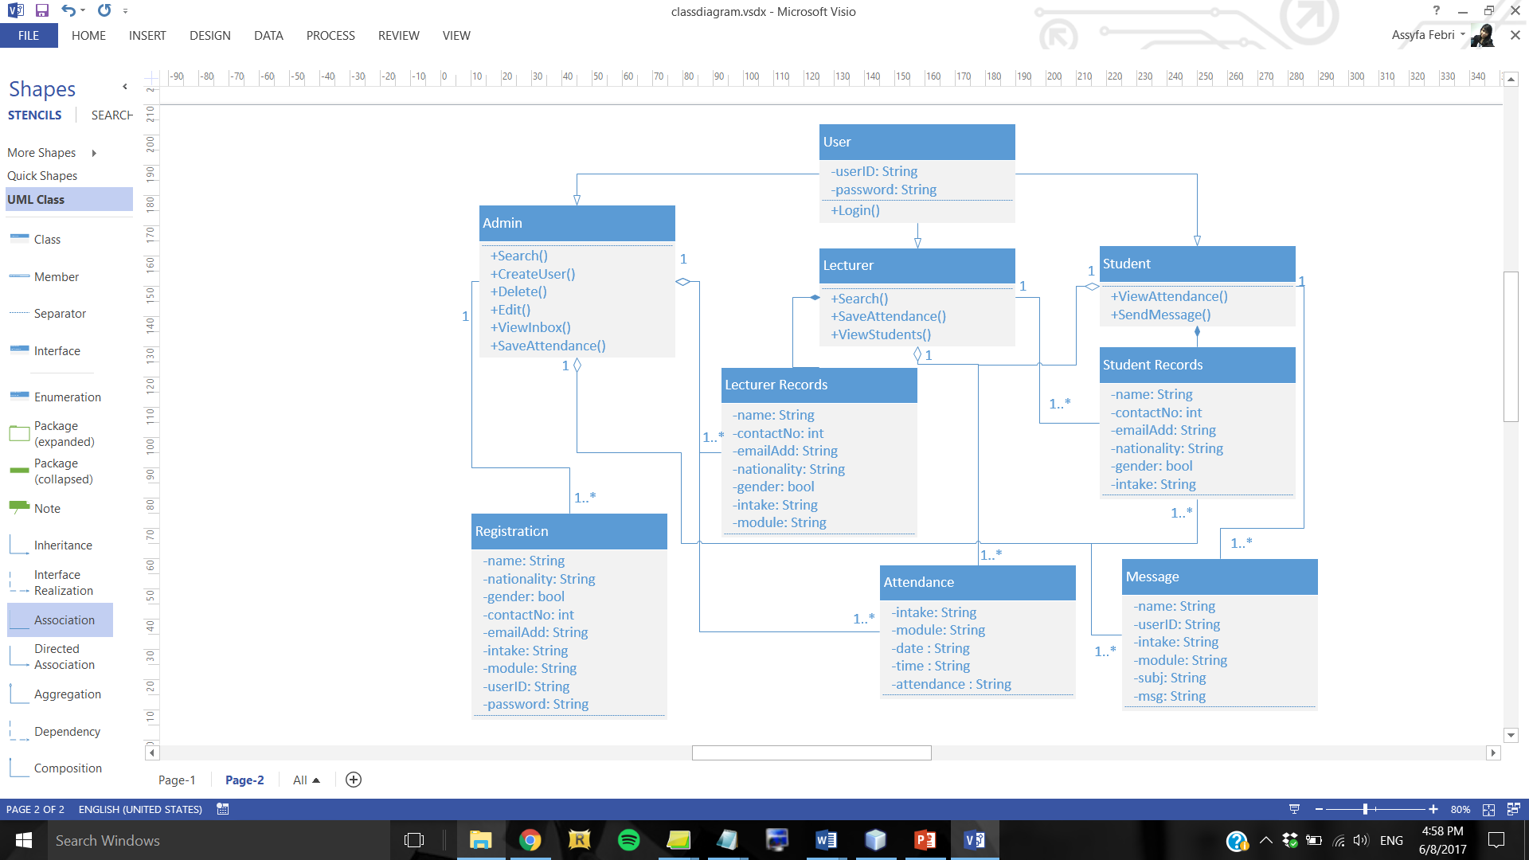

*Figure 2.2: Class Diagram*

## 2.3 Activity Diagram

### 2.3.1 Admin

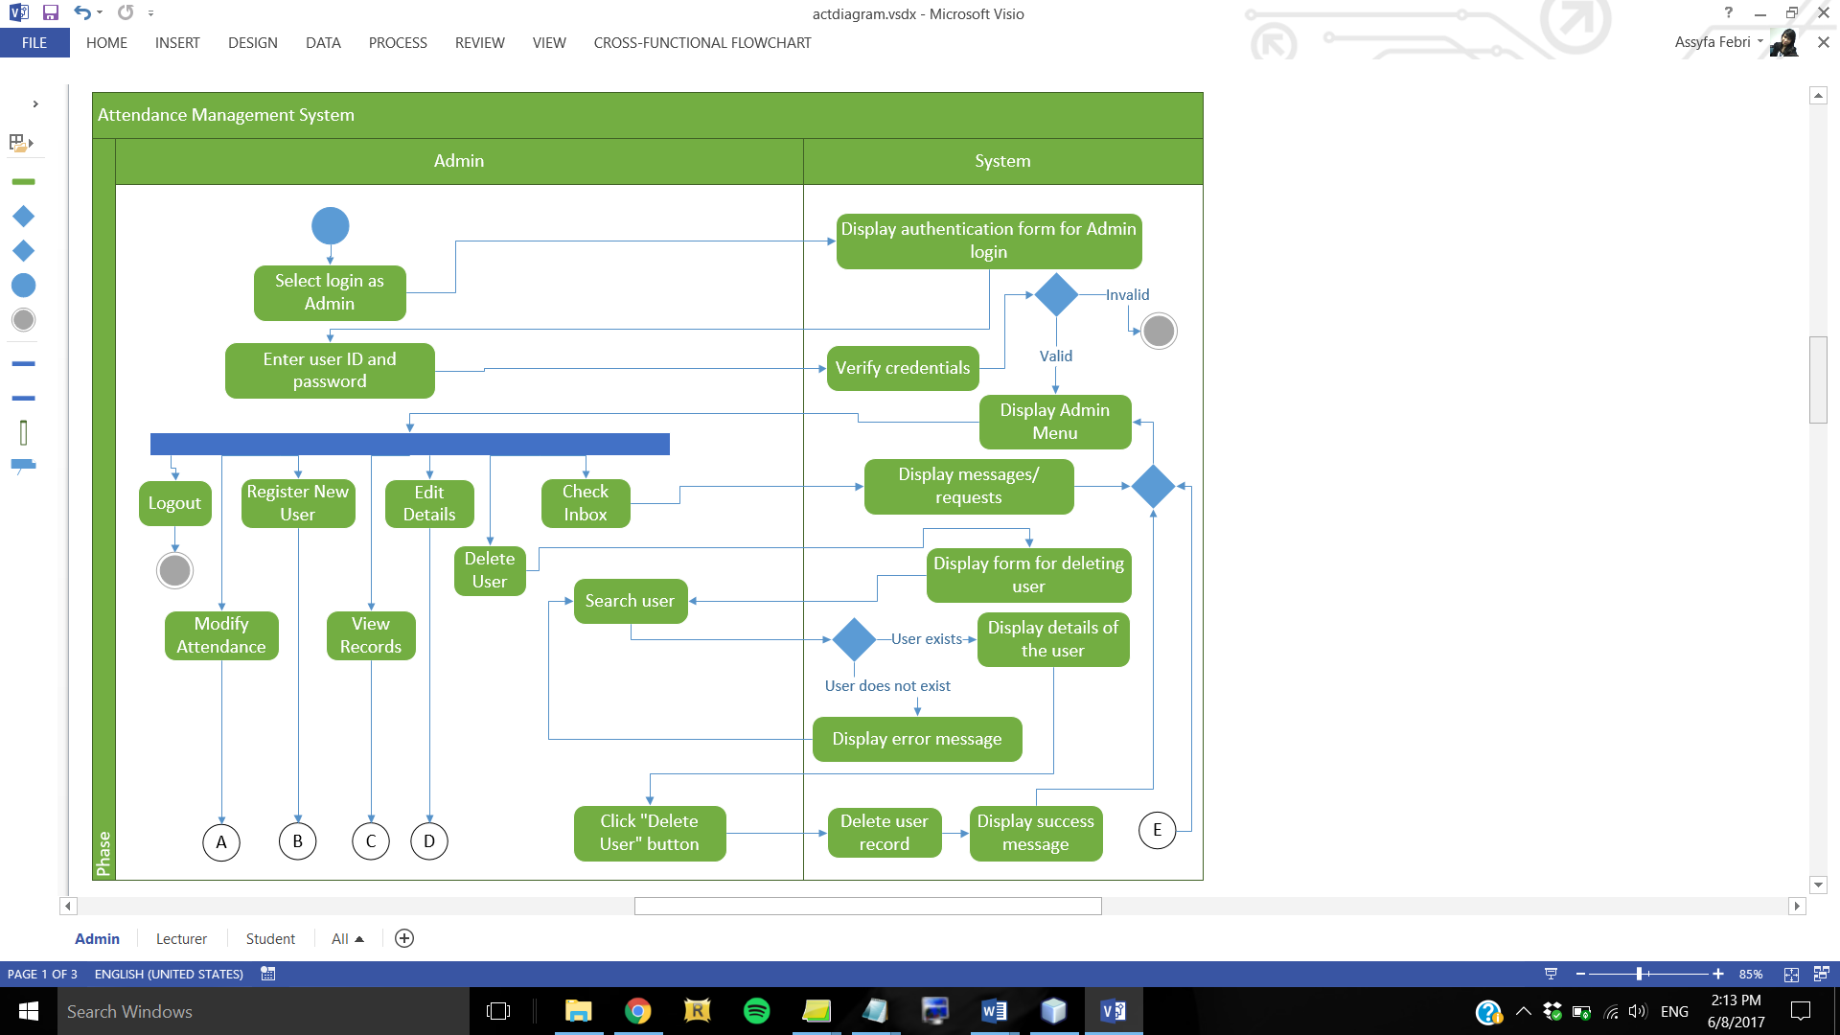

*Figure 2.3.1.1: Activity Diagram for Admin – Part 1*

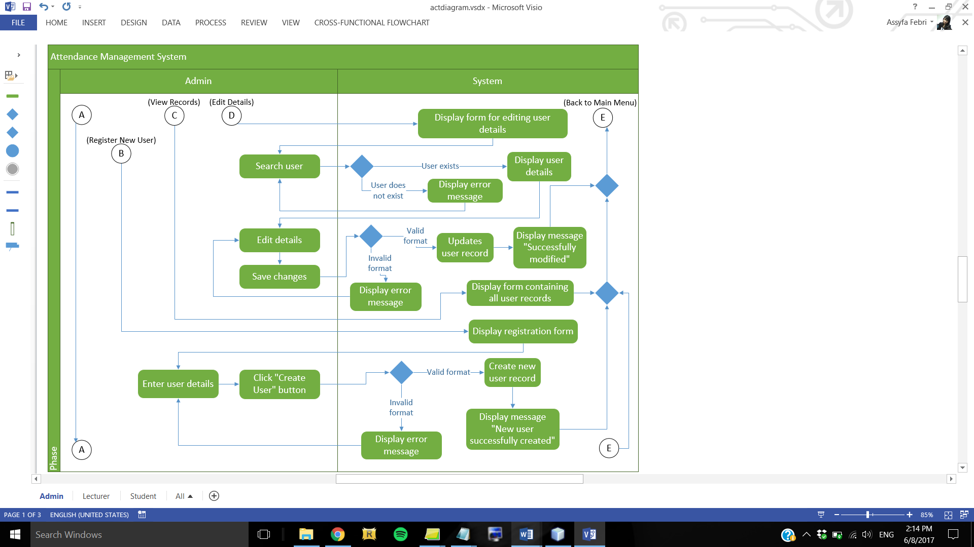

*Figure 2.3.1.2: Activity Diagram for Admin – Part 2*

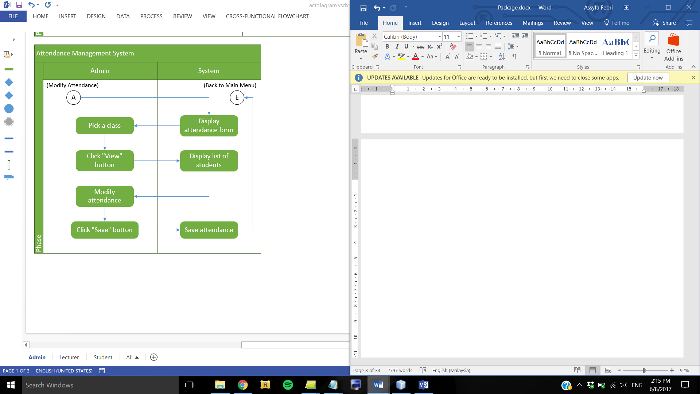

*Figure 2.3.1.3: Activity Diagram for Admin – Part 3*

### 2.3.2 Lecturer

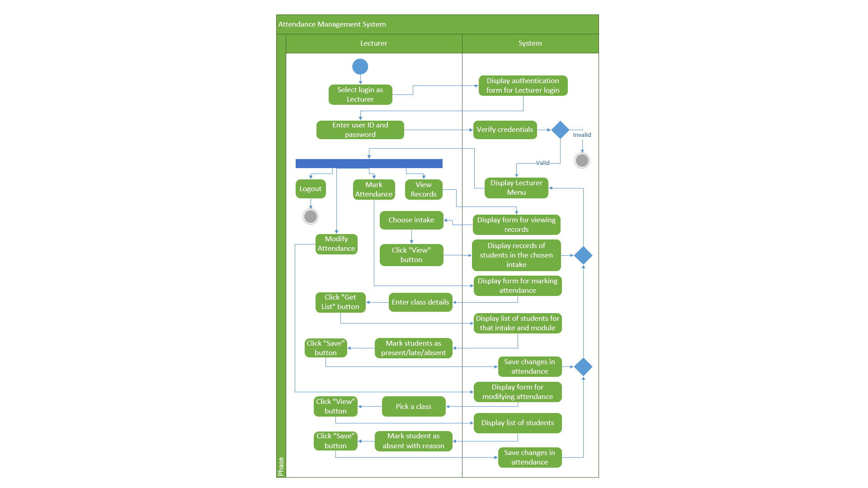

*Figure 2.3.2: Activity Diagram for Lecturer*

### 2.3.3 Student

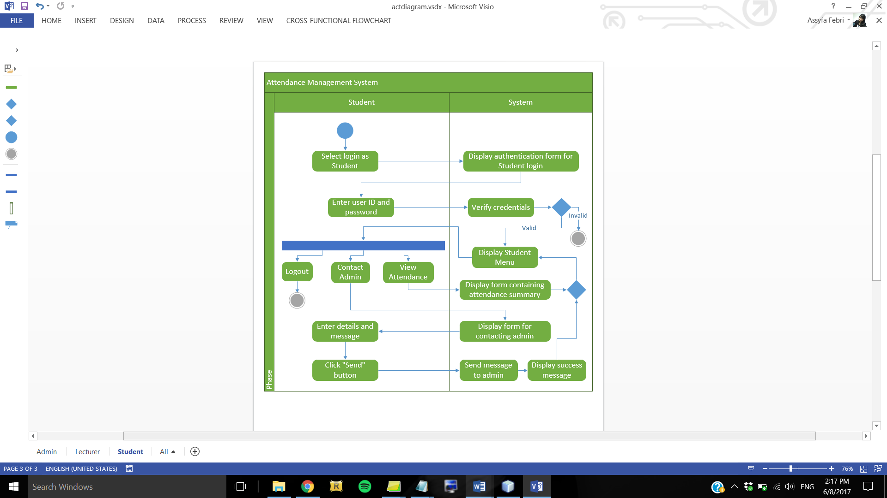

*Figure 2.3.3: Activity Diagram for Student*

# 3.0 Object Oriented Programming Concepts

## 3.1 Package

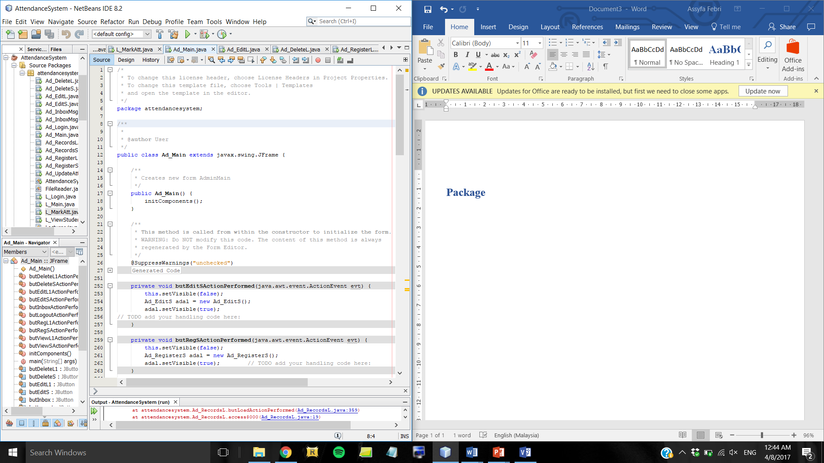

Every class starts with the package name. A java package is a way to organise classes into namespaces which means that classes in the same package belong to the same category, therefore preventing class name collisions (Brendel, 2009). For instance, if there are 2 classes with the same name, Menu, but belonging to different packages, such as BookingSystem and AttendanceSystem, when the attendance system program is run it will only call the Menu class which contains “package AttendanceSystem” and not the other Menu class because it belongs to a different project.

For this assignment, each relevant class in the attendance management system starts with “package attendancesystem” which tags that this particular class belongs to this particular project. Grouping related classes into packages is important because a Java software can be composed of thousands of individual classes, thus it should be done to keep things organised (Oracle, 2015).

## 3.2 Import

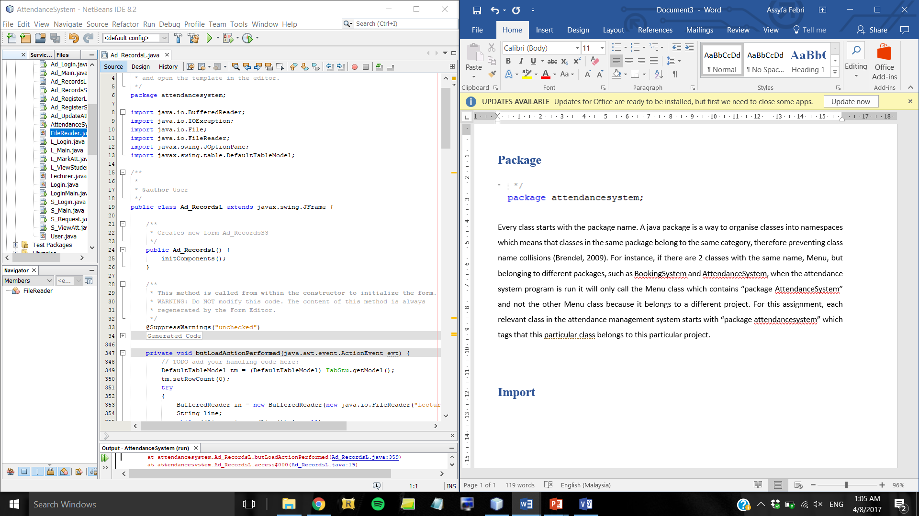

Import statements are used to name and import the built-in and user-defined packages from other libraries (Swartz, 2017). This allows a class within the Java program to refer to another class placed in another package directly using its name, thus using methods which are located outside of the project’s package. The import statement must be placed after the package statement and before class declaration (tutorialspoint, 2017). The format is import declaration, followed by package name and desired class name within the package.

In this case, “java.io” is the name of the existing Java package which contains classes for input and output functions, followed by “BufferedReader” which is the class to be called from that package. The File and FileReader classes from the java.io package also need to be imported because they are needed to read data from a file, such as Student_Records file for Admin to view student records.

## 3.3 Class

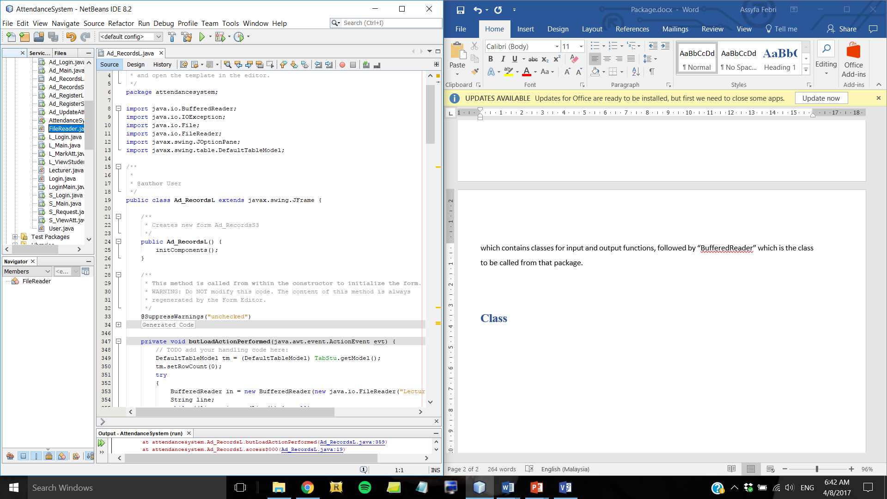

A class is a template for creating objects and contains data types and methods to describe the object’s behaviour (Wideskills, 2015). It is declared by writing the class keyword followed by the name of the class with a pair of curly brackets ({}) that delimit the class’s body. A class body may consist of variables, methods, and constructors. A class does not have to be designed specifically for object creation, it may also exist as a storage for class methods and fields which are to be called from another class (Friesen, 2015). This type of class is called a utility class. Classes can also be declared as public using the public keyword but it must have the same name as the file which stores the class, and there may only be one public class in a source file.

In this case, the Ad_RecordsL class is a public class which has the same name as its source file. This class acts as a container which stores variables and methods that are used for viewing lecturer records.

## 3.4 Object

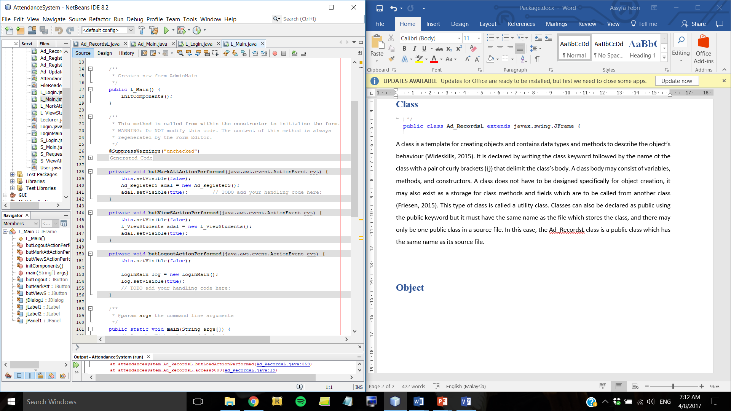

By definition, an object is an entity that has its own state and behaviour (javatpoint, 2017). An object is created from a class which provides the blueprint for objects. It is declared by stating the name of the class that the object shall be created from, the name of the object, followed by the new keyword that instantiates the object by calling a constructor as defined afterwards (Oracle, 2015). In this case, the object “log” calls the LoginMain constructor of LoginMain class to display the LoginMain form.

## 3.5 Encapsulation

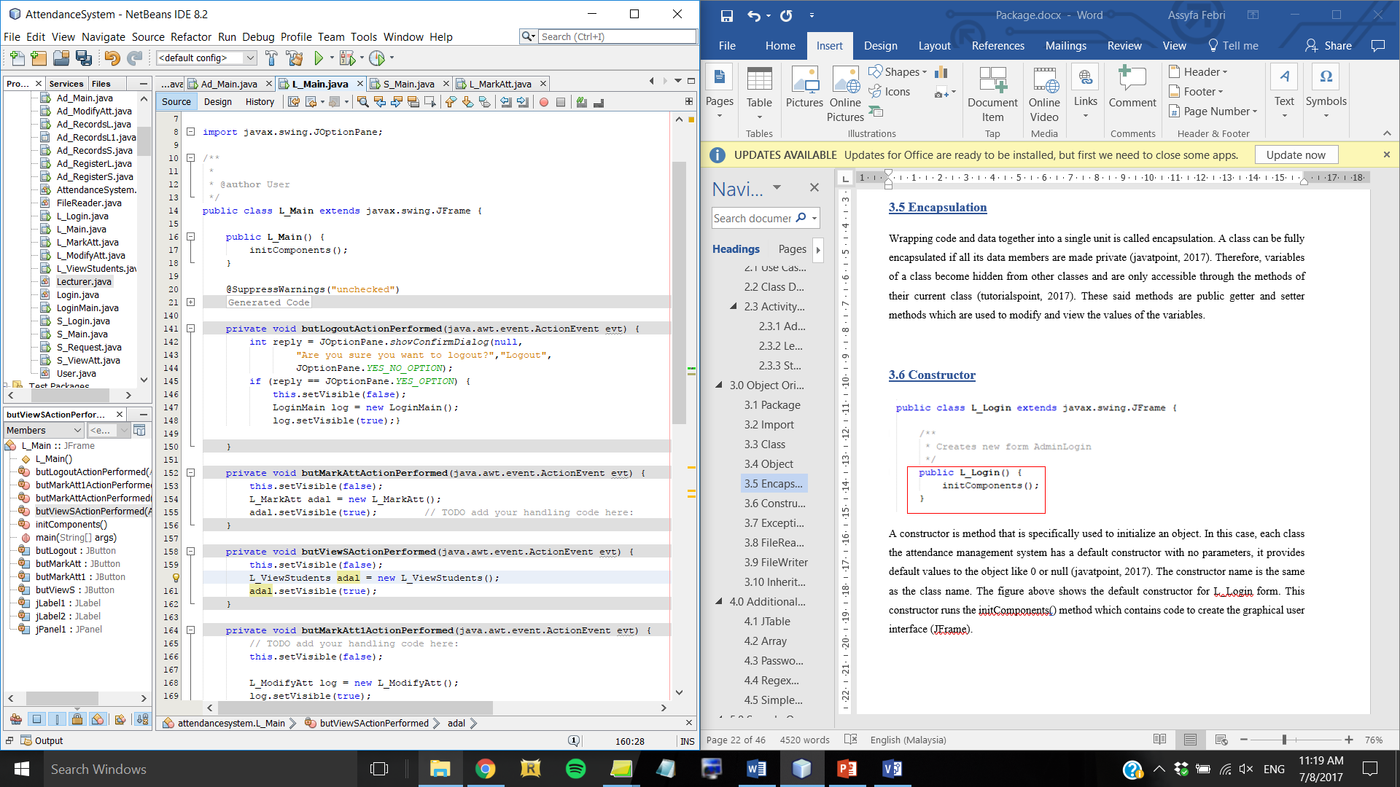

Wrapping code and data together into a single unit is called encapsulation. A class can be fully encapsulated if all its data members are made private (javatpoint, 2017). Therefore, variables of a class become hidden from other classes and are only accessible through the methods of their current class (tutorialspoint, 2017). In the example above, the methods inside the buttons are marked as private which means it is encapsulated within the L_Main class, thus the variables inside the method can only be called by that method of that class.

## 3.6 Constructor

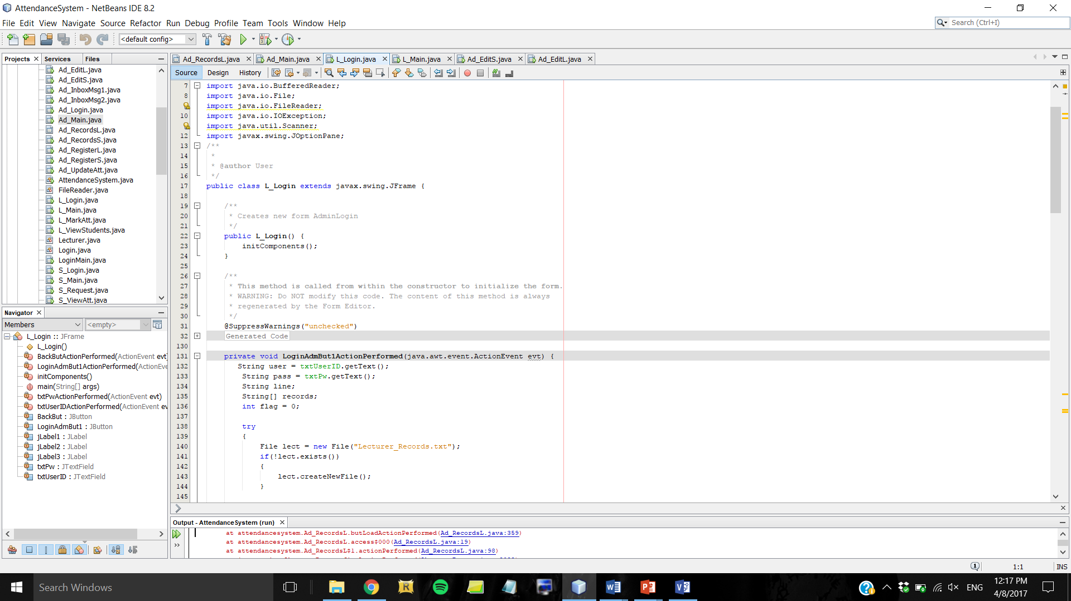

A constructor is method that is specifically used to initialize an object. In this case, each class the attendance management system has a default constructor with no parameters, it provides default values to the object like 0 or null (javatpoint, 2017). The constructor name is the same as the class name. The figure above shows the default constructor for L_Login form. This constructor runs the initComponents() method which contains code to create the graphical user interface (JFrame).

## 3.7 Exception Handling

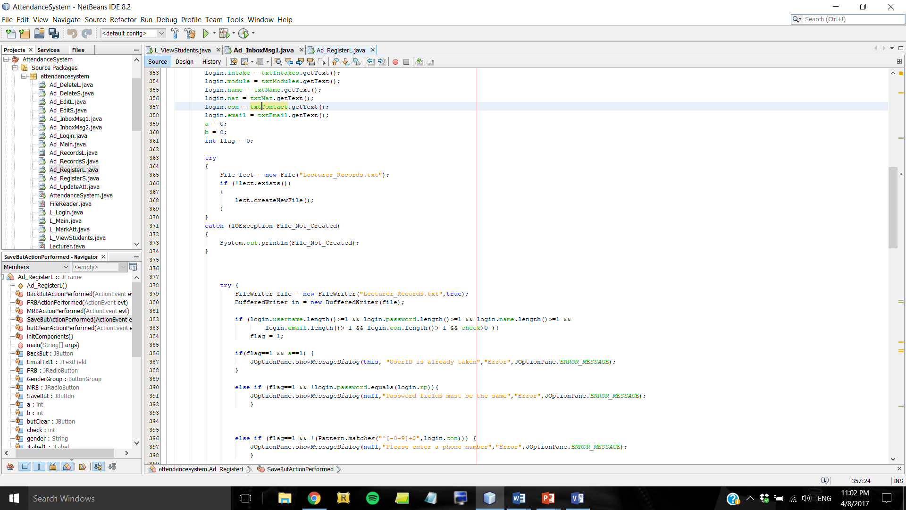

To perform exception handling function, the first step is to enclose the code that might throw an exception within a try block, and the code that handles the exception in the catch block (Oracle, 2015). Each try block must be followed by a catch block after it. If an exception happens in the try block, it is caught up by the corresponding catch block to be handled. A finally block could be added after the catch block. The code inside it will execute regardless of whether or not there was an exception thrown and handled by the try and catch blocks (Singh, 2017).

The figure above shows an example of exception handling within the search button in Ad_RegisterL form. Inside the try block, FileReader has to read data from Lecturer_Records.txt as specified, however there is a possibility that the file does not exist therefore an exception might be thrown. When an exception is thrown because the file does not exist, it will be handled by the code in catch block which will display a message the text file cannot be found. The type of exception is IOException because the File object does not contain methods for reading/writing data from/to a file, therefore Java I/O classes are needed to perform I/O, thus the exception thrown from FileReader would be IOException with the error name of File_Not_Created.

## 3.8 FileReader

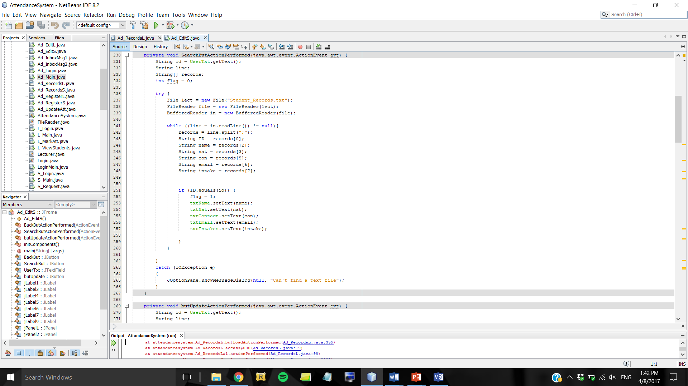

In this case, the FileReader reads the data from a file object which is Student_Records.txt. Since the file is written in array, variables are assigned values according to the index number. The variables are then assigned to the text fields to display output. BufferedReader is also wrapped around the FileReader as it reads the text from a file by buffering characters, thus it reads characters, arrays, or lines efficiently (Guru99, 2017).

According to the figure above, it was declared that the first array index [0] in the file is the value of ID variable, thus if the ID value is the same as id value (the value that user entered in the search bar) then it will read that particular line in the file and set the text fields according to the records of that line. This means details (name, nationality, contact number, email address, assigned intakes) of the lecturer which has the same ID as what the user inputted will be displayed in the text fields in JFrame.

## 3.9 FileWriter

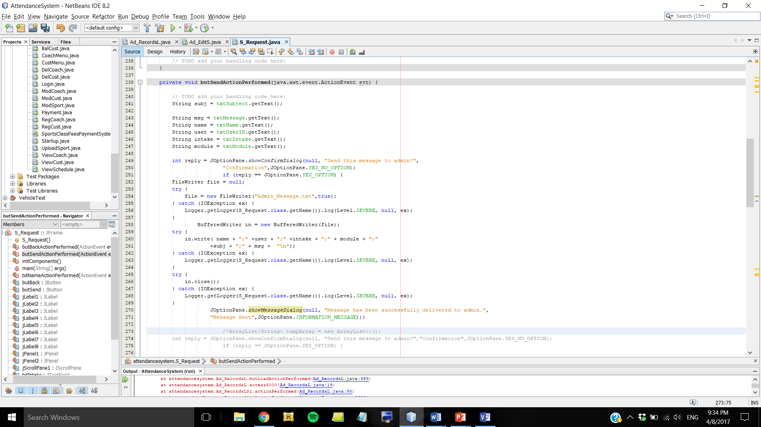

The use of the FileWriter class is to write characters to a file (Jenkov, 2015). In this case, FileWriter is applied to the Send button in the S_Request form which is to write the message that students entered to be sent to admin. By setting the last parameter to true, it appends the characters to an existing file instead of overwriting it. The FileWriter is coupled with BufferedWriter which provides buffering of character for efficient writing of strings, arrays, or character data to the file (Singh, 2017).

In this case, it was declared that the FileWriter will write to Admin_Message.txt. By utilising BufferedWriter object called “in”, it will write the values of the variables (details of the sender and message for admin) in the appropriate order/format as defined by user.

## 3.10 Inheritance

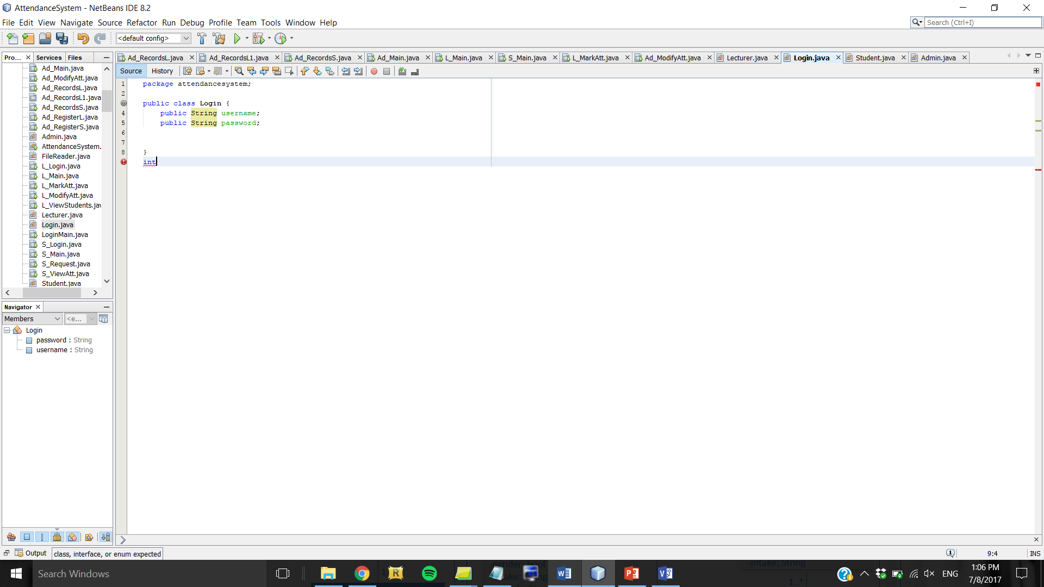

*Figure 3.10.1: Parent class (Login) contains username and password variables which are inherited by child classes (Lecturer, Student, Admin)*

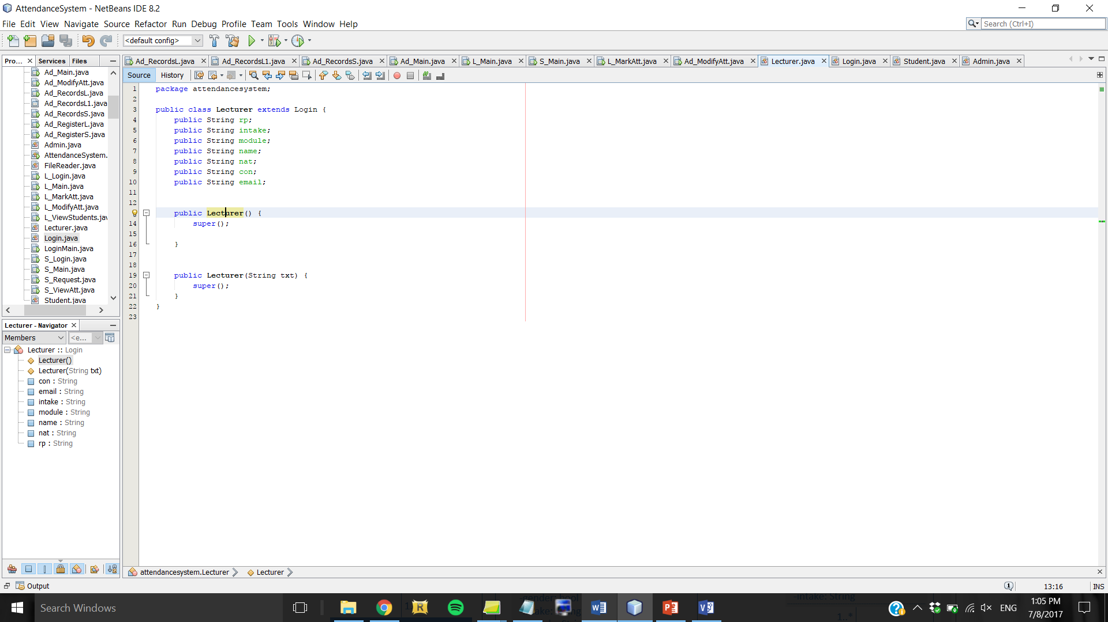

*Figure 3.10.2: Lecturer is a child class that inherits from parent class (Login)*

In this case, Lecturer is the name of the child class who inherits properties (variables and methods) from the parent class (tutorialspoint, 2017) which is Login. The keyword “extends” indicates the concept of inheritance. Login class contains common variables for all types of users, which are username and password, whilst Lecturer class contains other variables that Admin class (another child class which inherits from Login class) does not have. Therefore, an object that calls the Lecturer class can use variables and methods from the Login class as well because Lecturer class inherits from it.

# 4.0 Additional Features

## 4.1 JTable

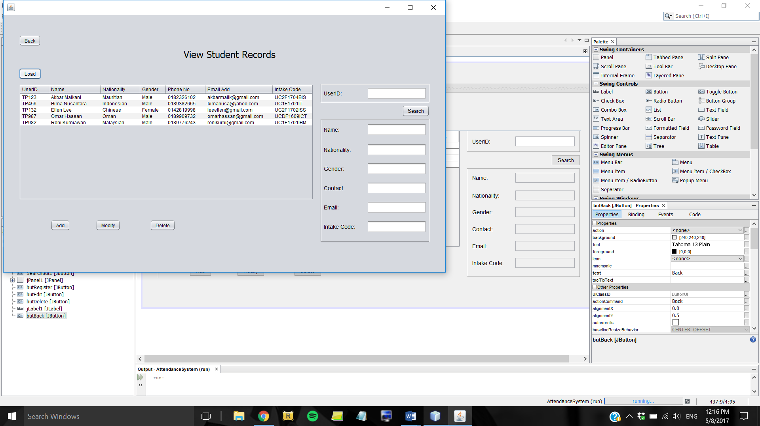

*Figure 4.1.1: JTable in Ad_RecordsS class which displays student records*

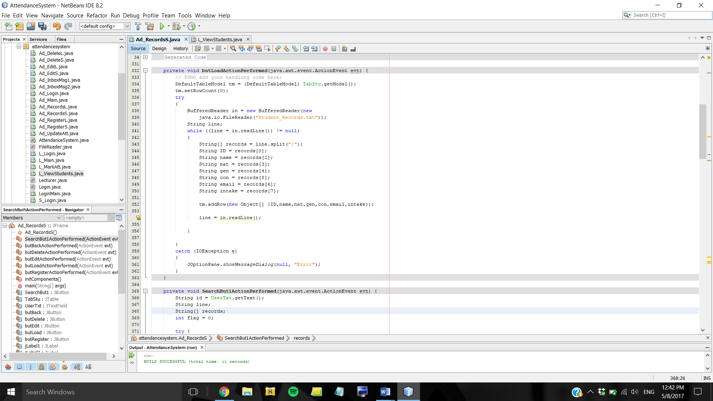

*Figure 4.1.2: Code snippet from Ad_RecordsS class which contains DefaultTableModel to connect to JTable*

In the figure above, JTable is used to display a list of students and their details. To be able to get data to be displayed in the JTable, there needs to be DefaultTableModel class imported from javax.swing.table package. This ensures that whatever data is read from the text file will be written into the table defined in “TabStu.getModel()”. The DefaultTableModel object is named tm, thus in the while loop that is reading the Student_Records file it was declared “tm.addRow” which means that a new row will be added to the TabStu table containing data (in array form) read from the text file.

## 4.2 Array



*Figure 4.2.1: Code snippet from Ad_RecordsS class which contains array declaration*

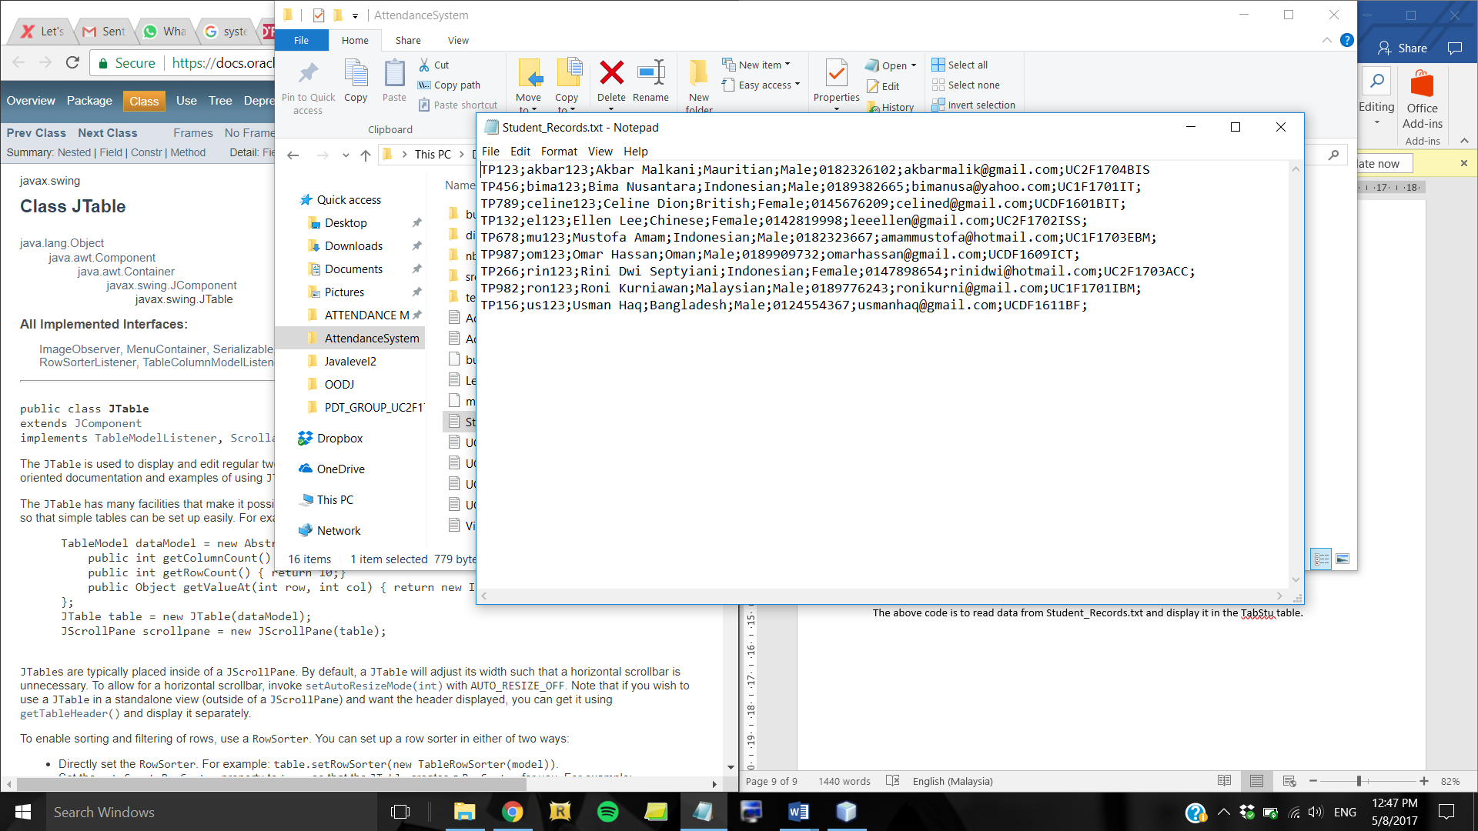

*Figure 4.2.2: Text file in which the array is based on*

The above code is to read data from Student_Records.txt and display it in the TabStu table. The text file stores a collection of details with “;” as the separator. Therefore, to separate between one detail to another the system must read the data as an array with “;” separator. The string array [] is declared as “records”. Each variable is assigned a value from the array using the array’s index number. For example, ID has the value of the first data in the array (records[0]) whilst name contains the value of third data in the array (records[2]), and so on.

## 4.3 Password Field

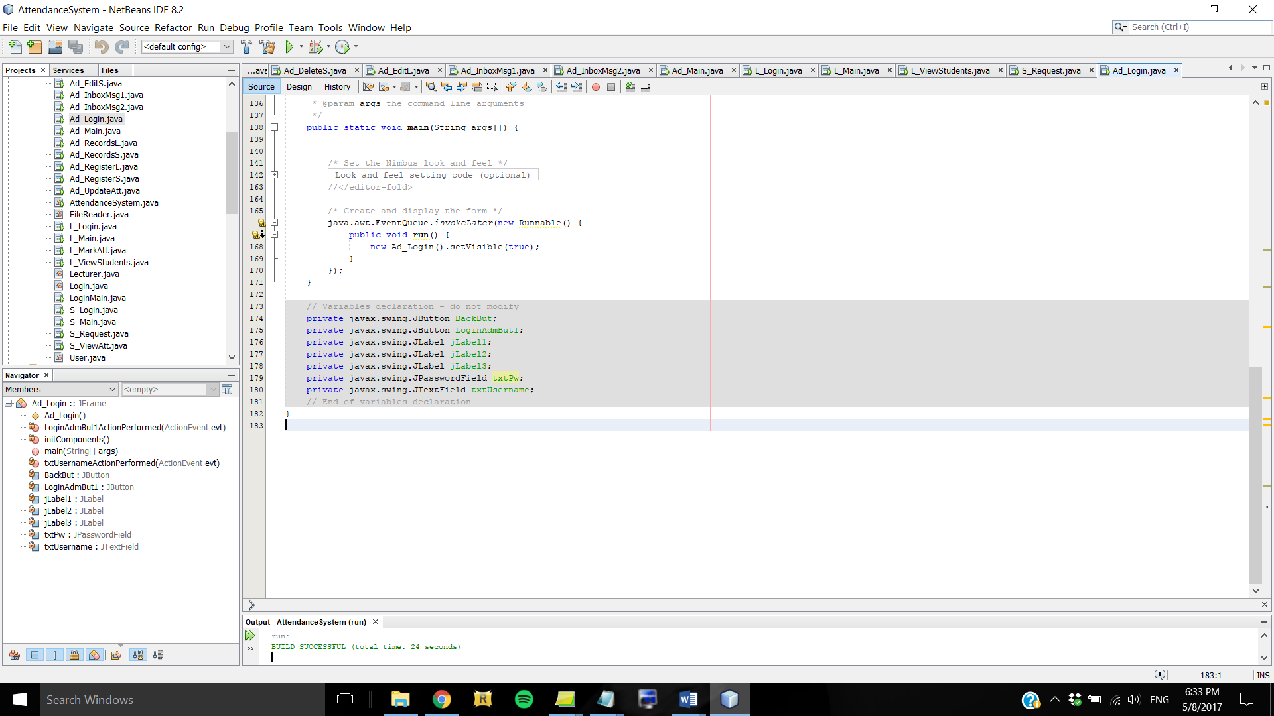

By using JPasswordField, the characters are hidden as user types, instead the field displays an asterisk in place of a character (Oracle, 2015). This is used for hiding passwords for security reasons when user is logging in as Admin, Lecturer, or Student.

## 4.4 Regex Pattern Validation

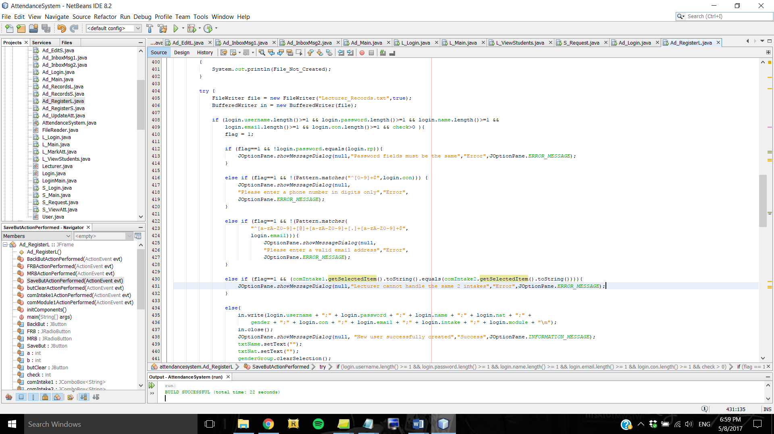

The Java Regex (Regular Expression) is used to define constraint on strings such as phone number and email address validation (javatpoint, 2017). It is used by this system for validation of phone number and email address in the registration and edit details forms. By declaring the phone number pattern as “^[0-9]+$” it means that the text user enters in that field has to be numbers between 0-9 only, without any alphabets and other characters. If the pattern does not match, an error message will show up notifying user that the phone number has to be in digits only. It is also applied to the email address field whereby it was declared that the format of email address has to be any uppercase or lowercase alphabets and/or numbers, followed by the @ symbol, followed by alphabets and/or numbers, followed by a full stop (.), and ends with alphabets and/or numbers. If user’s input does not match this pattern, an error message will be prompted to inform user to enter a valid email address.

## 4.5 SimpleDateFormat

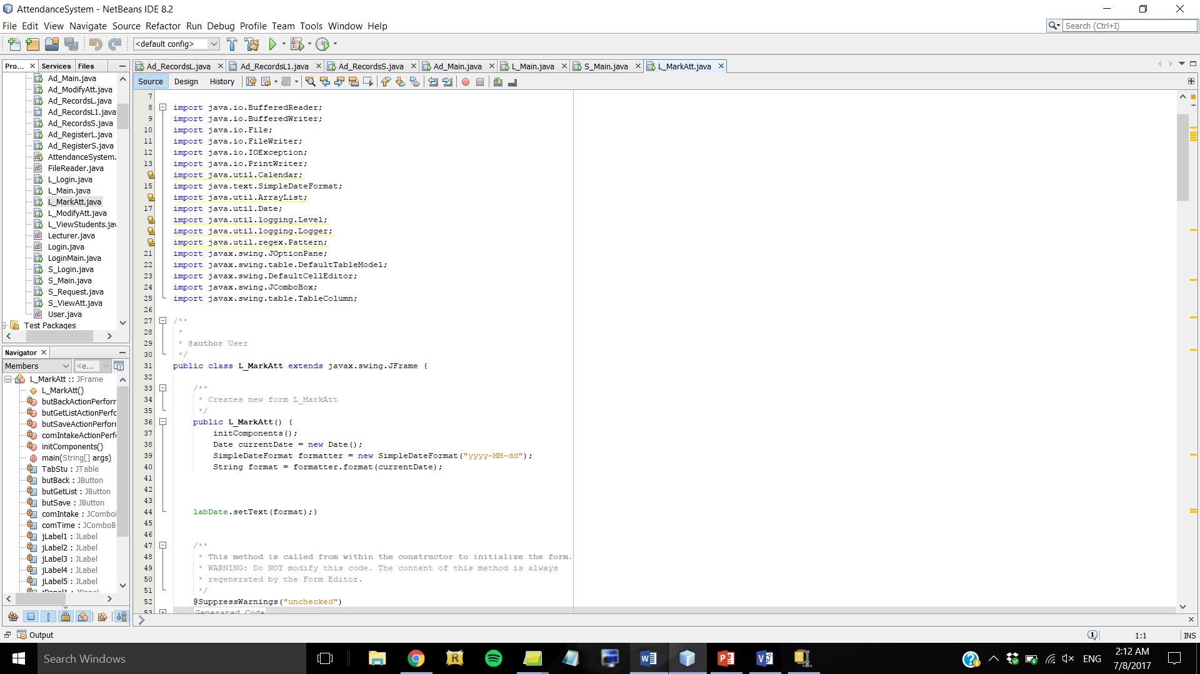

The SimpleDateFormat class is imported and used to display the current date in the Mark Attendance form for Lecturer. It allows the developer to set their own date pattern (java2s.com, 2017), which in this case is defined as “yyyy-MM-dd” which will show 4 digits of the year, 2 digits of the month, and 2 digits of the day. For example, 2017-08-06 for 6th August 2017.

# 5.0 Sample Output

## 5.1 Startup Form

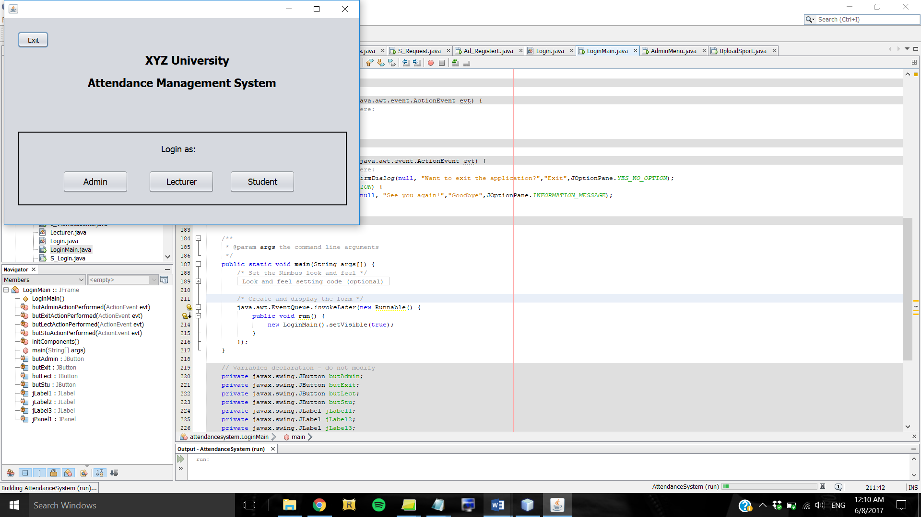

*Figure 5.1.1: GUI of the startup form*

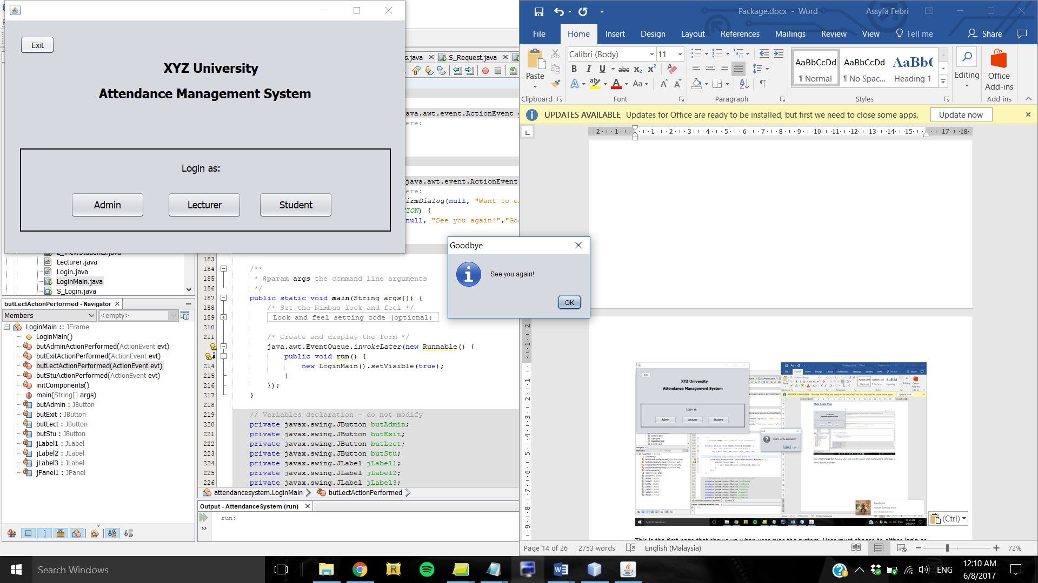

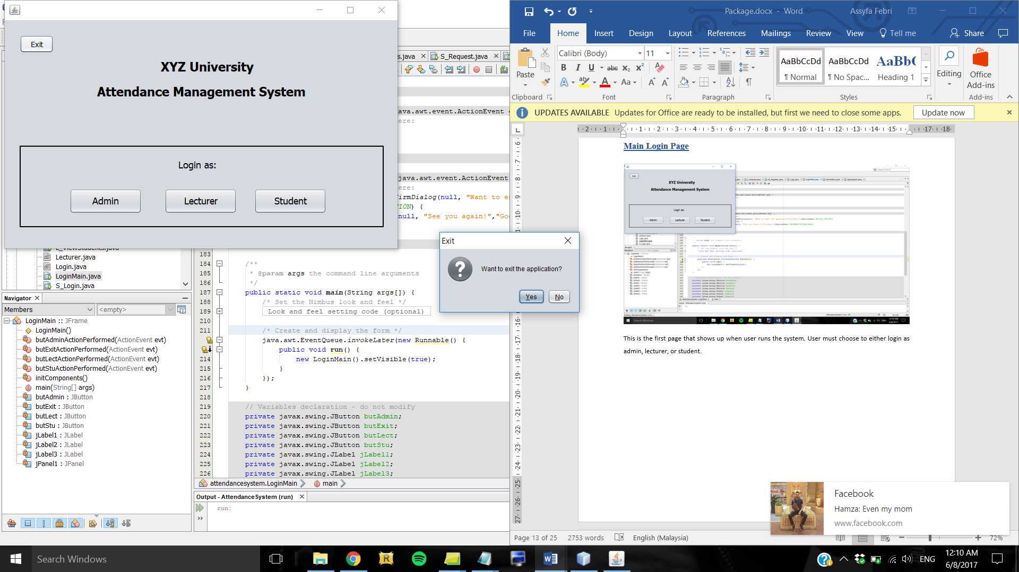

*Figure 5.1.3: Dialog box to indicate successful exit*

*Figure 5.1.2: Confirmation dialog box*

This is the first form that shows up when user runs the system. User must choose to either login as admin, lecturer, or student. If user wants to exit the application, they can do so by clicking the Exit button which will prompt a confirmation dialog box, if user clicks Yes then the application will close after showing a Goodbye pop-up message.

## 5.2 Login Form

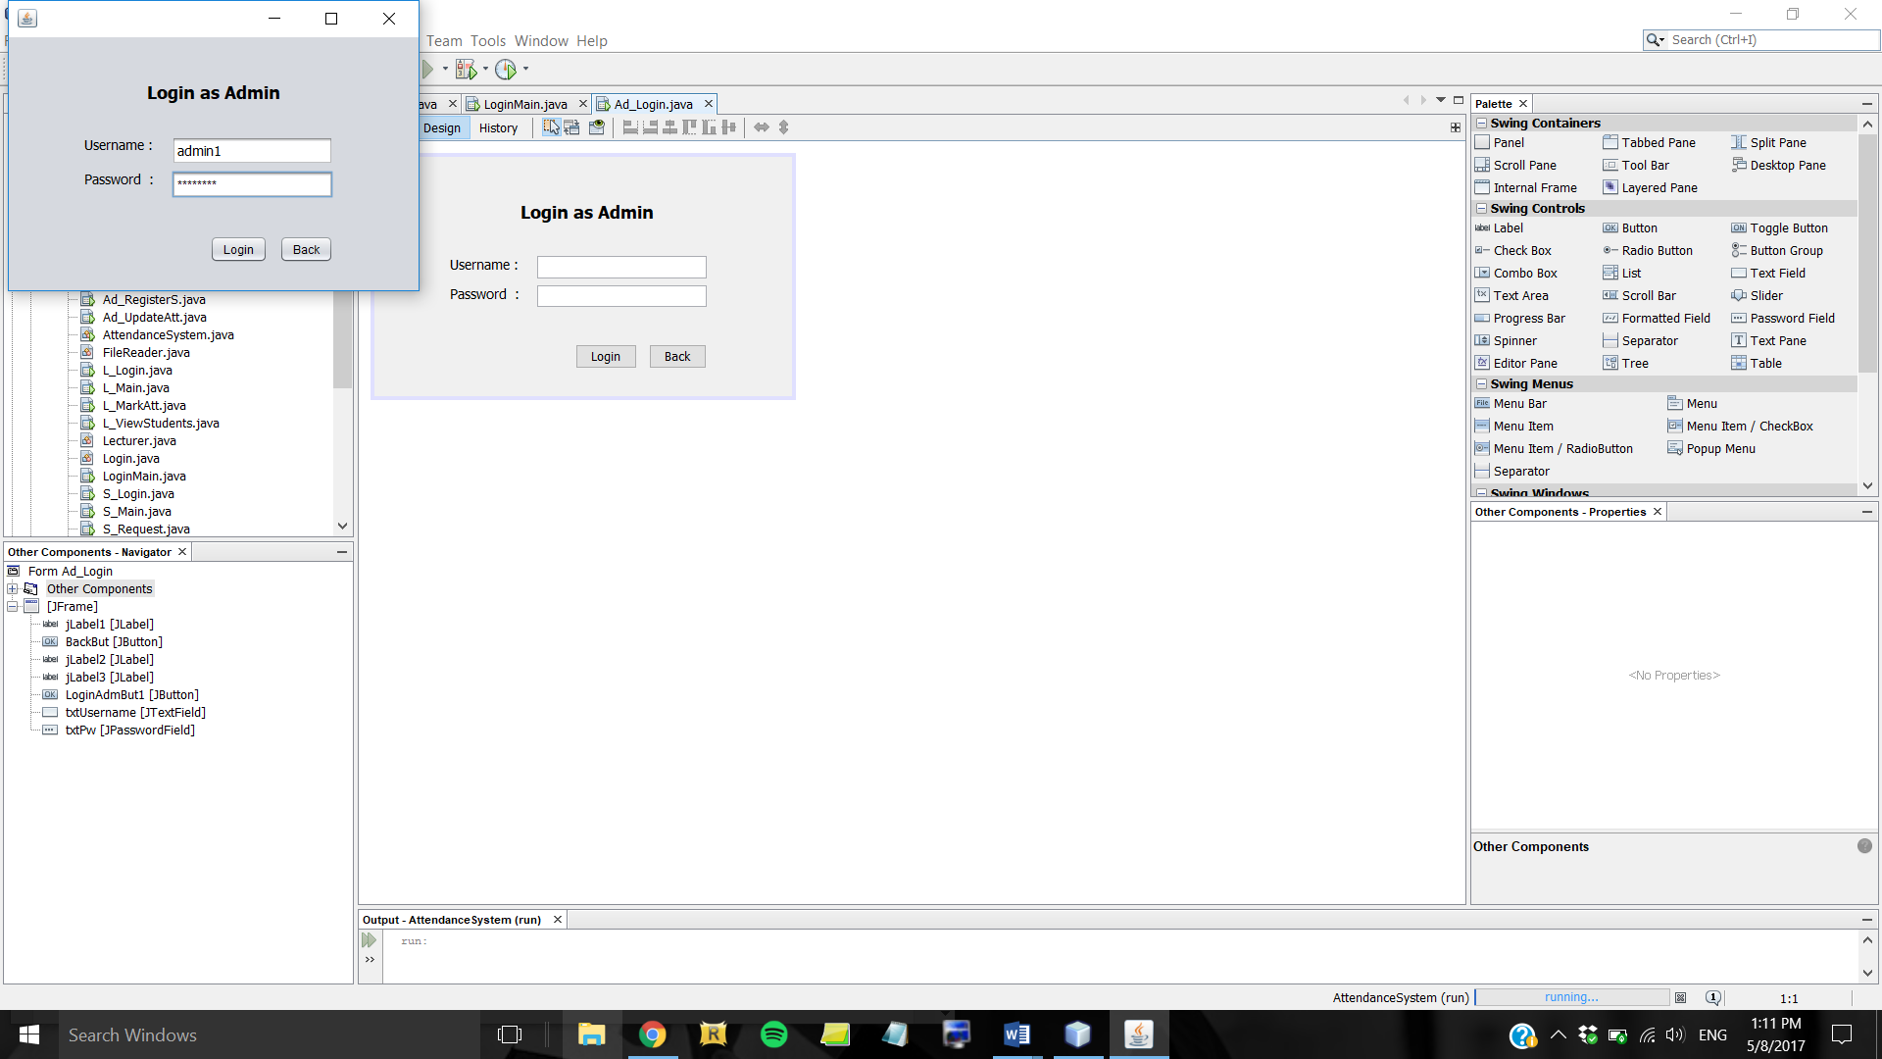

*Figure 5.2.1: Login form for Admin*

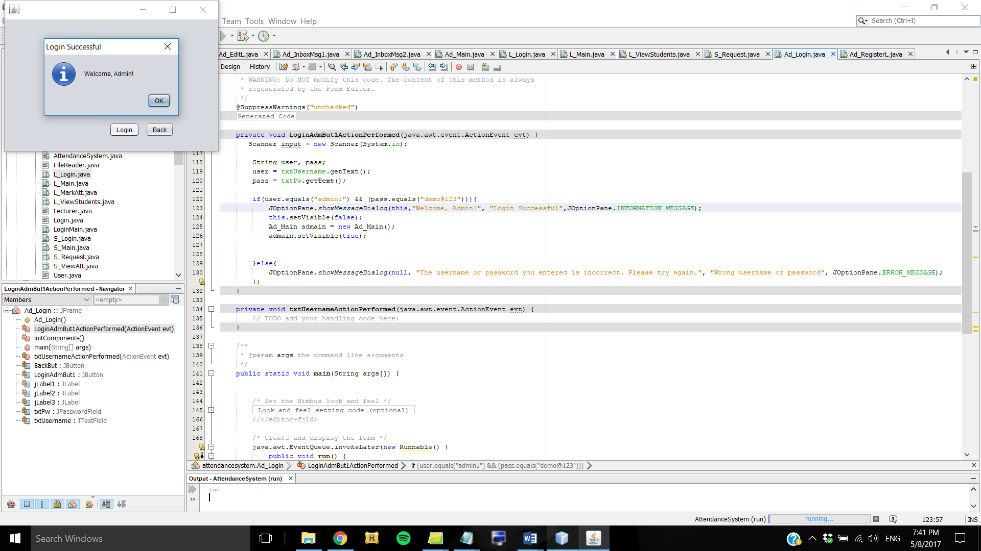

*Figure 5.2.2: Success message displayed if login is successful*

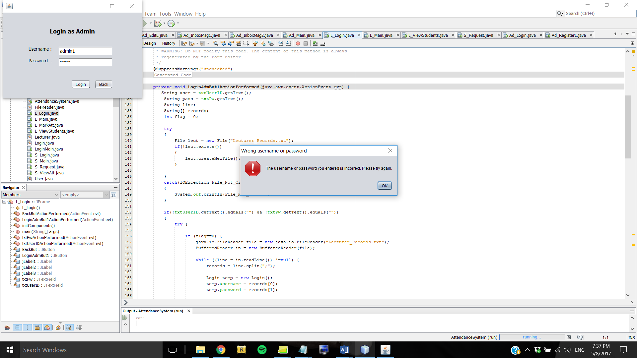

*Figure 5.2.3: Error message if invalid credentials were entered*

After choosing the type of user, user has to enter username and password then press the login button. The system will verify with the corresponding text file whether the username exists and the password matches. If everything is correct, a JOptionPane will show up to indicate that the login is successful. Otherwise, an error message will show up instead. There are 3 login forms, one for each type of user (Admin, Lecturer, and Student).

## 5.3 Main Menu Form

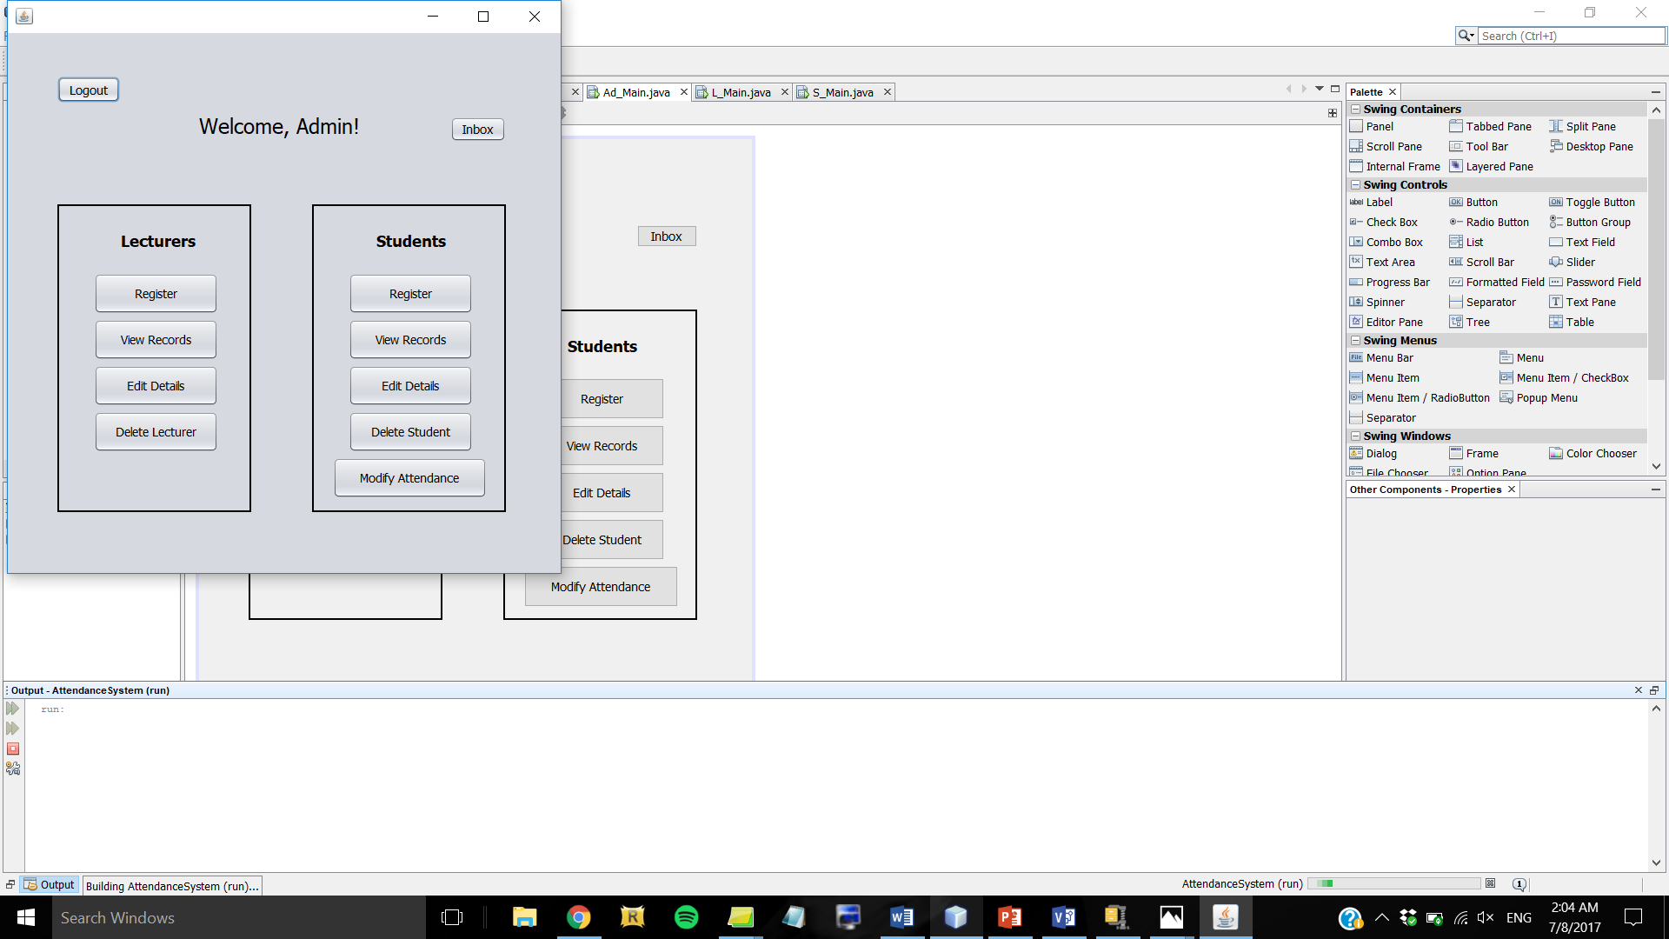

*Figure 5.3.1: Admin Main Menu*

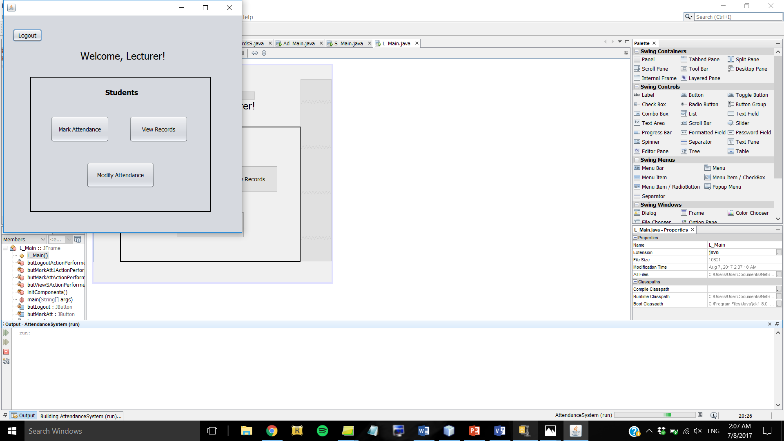

*Figure 5.3.2: Lecturer Main Menu*

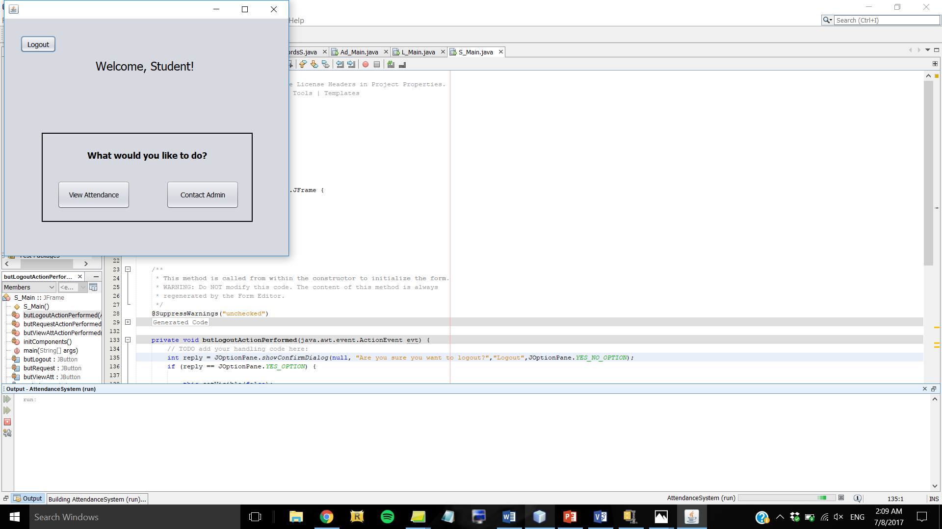

*Figure 5.3.3: Student Main Menu*

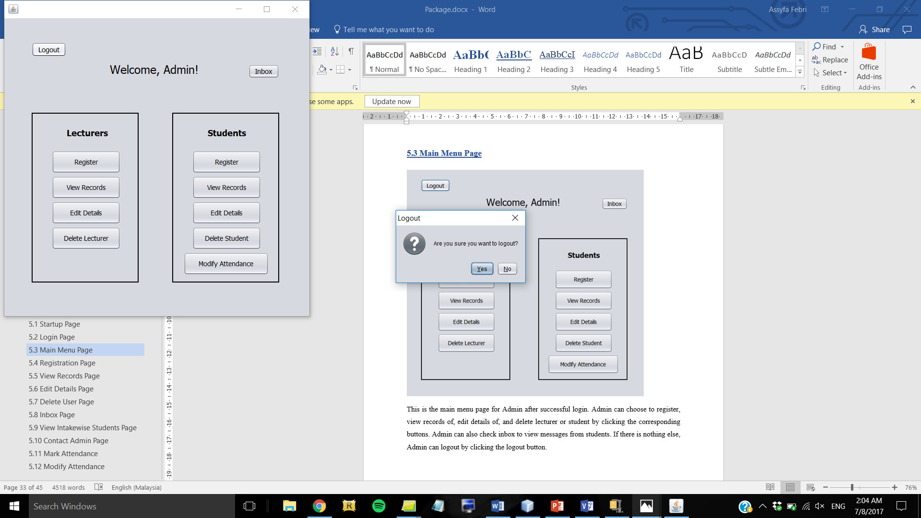

*Figure 5.3.4: Confirmation dialog box before logging out*

This is the main menu form for Admin after successful login. Admin can choose to register, view records of, edit details of, and delete lecturer or student by clicking the corresponding buttons. Admin can also check inbox to view messages from students. If there is nothing else, Admin can logout by clicking the logout button, and a confirmation dialog box will show up before logging the user out. Lecturer and Student also have similar layout for their main menu, with the logout button in common. But each has their own function buttons depending on what they can do with the system.

## 5.4 Registration Form

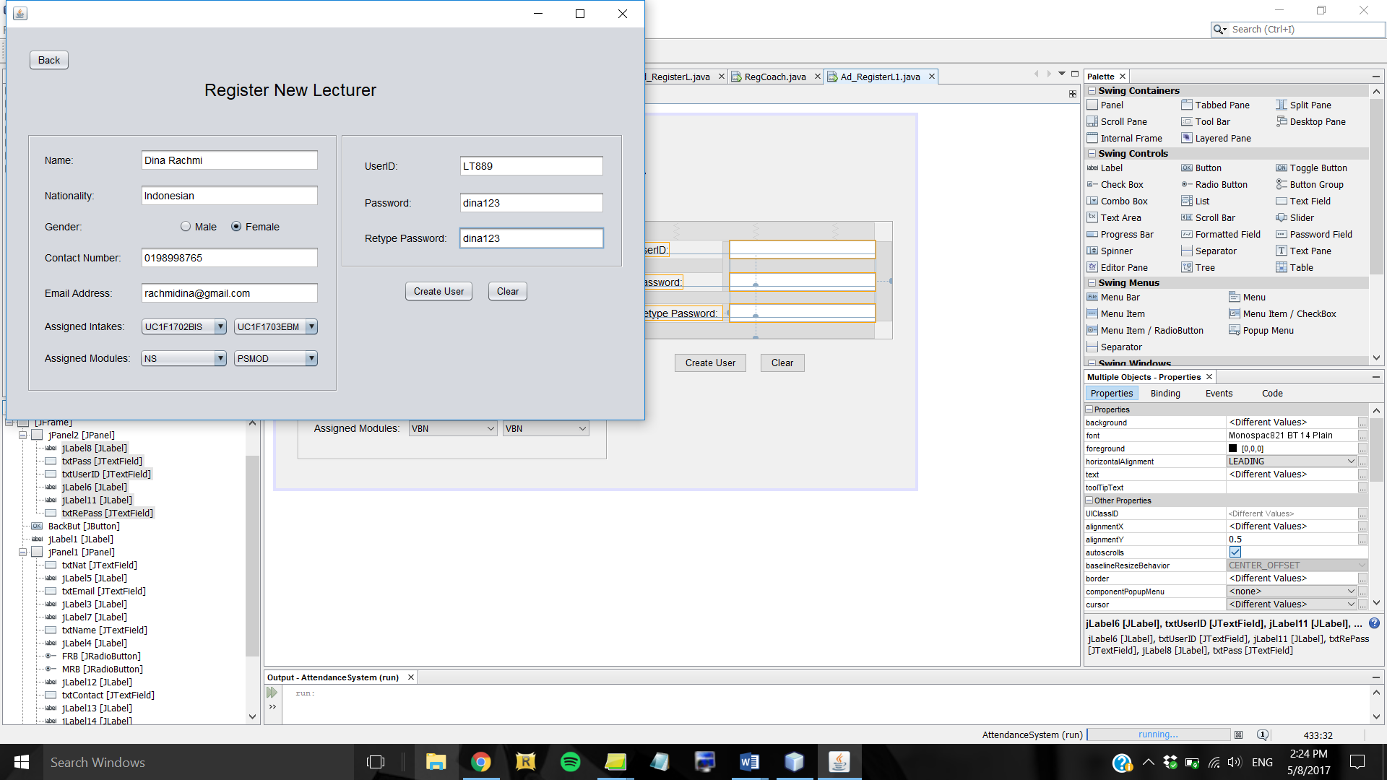

*Figure 5.4.1: Lecturer Registration Page*

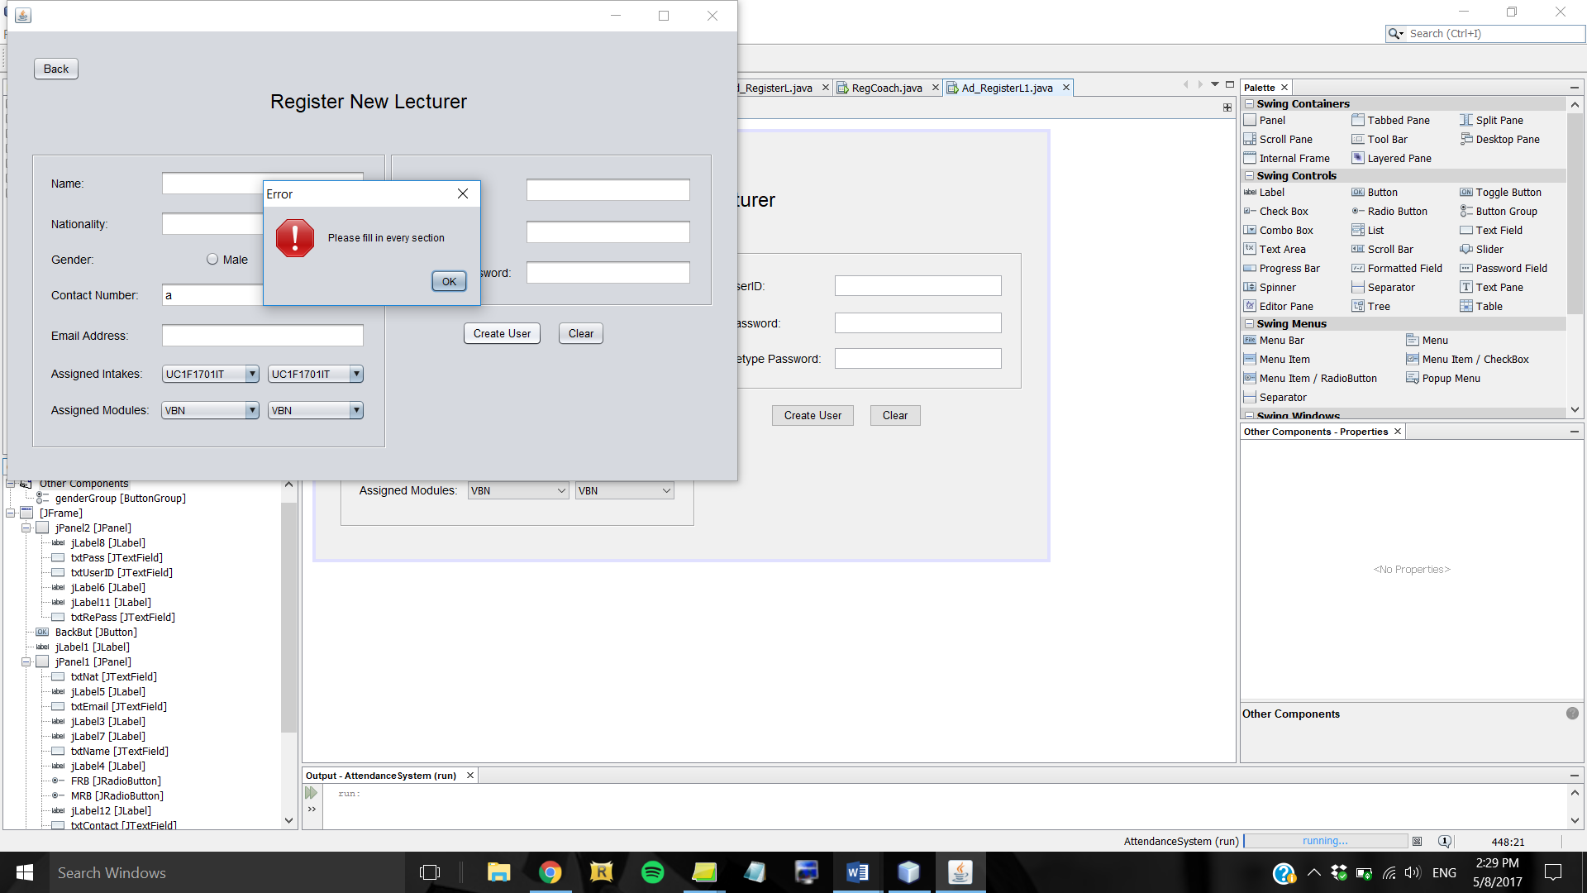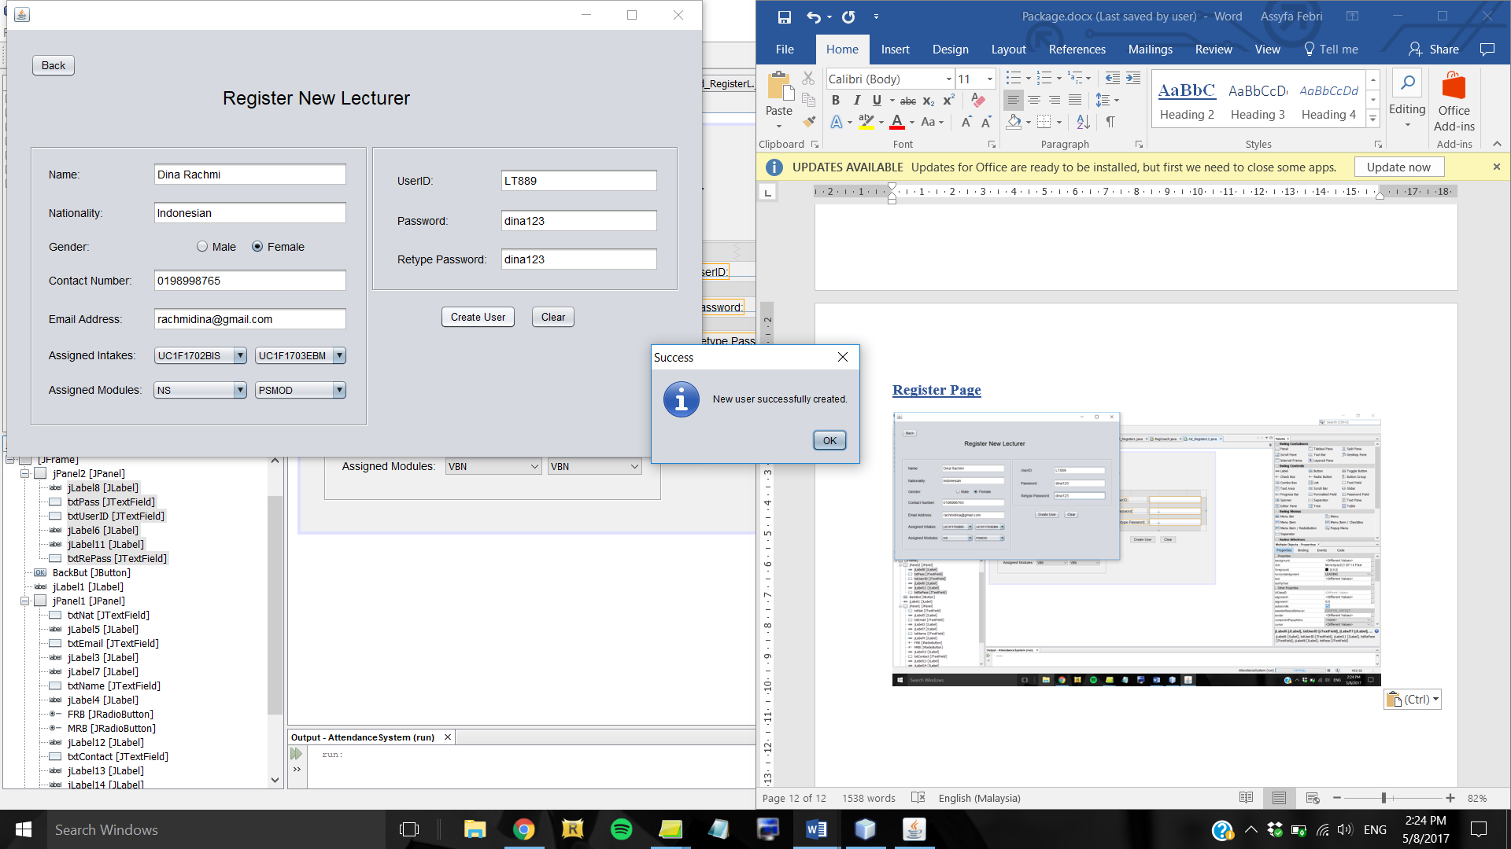

*Figure 5.4.3: Error message if one or more fields are left blank*

*Figure 5.4.2: Success message dialog box*

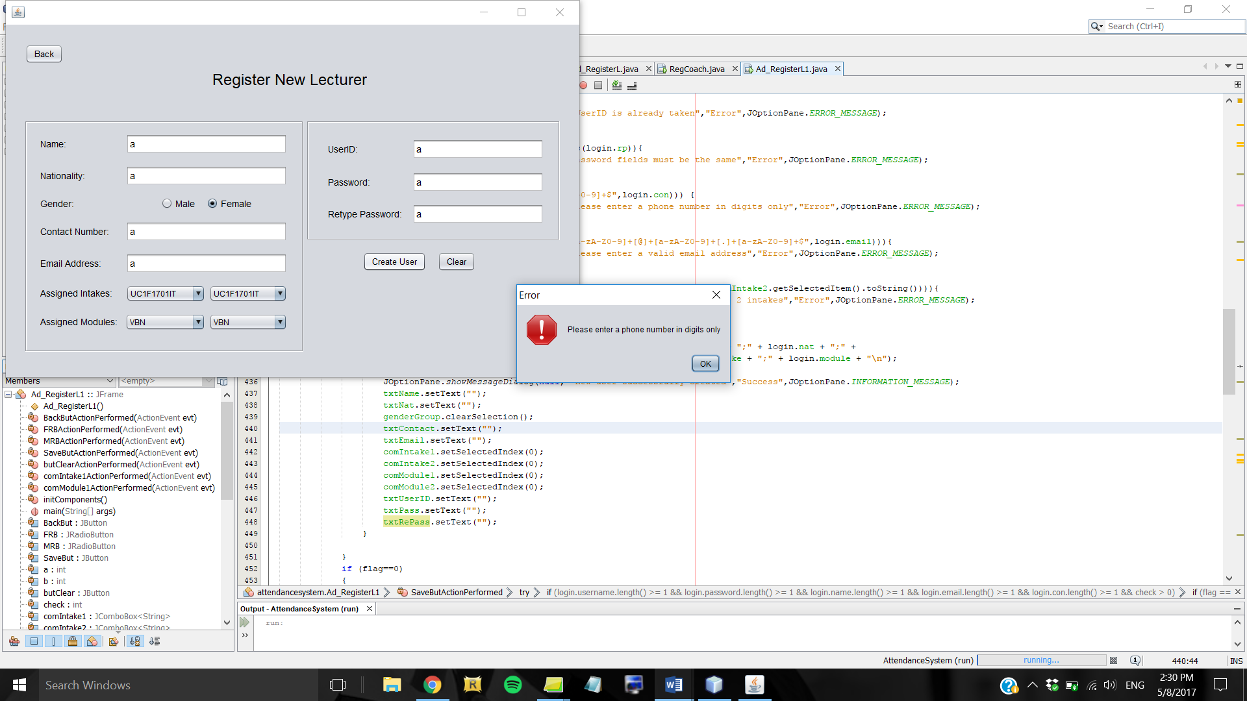

*Figure 5.4.4: Error message if wrong data type in the contact number field*

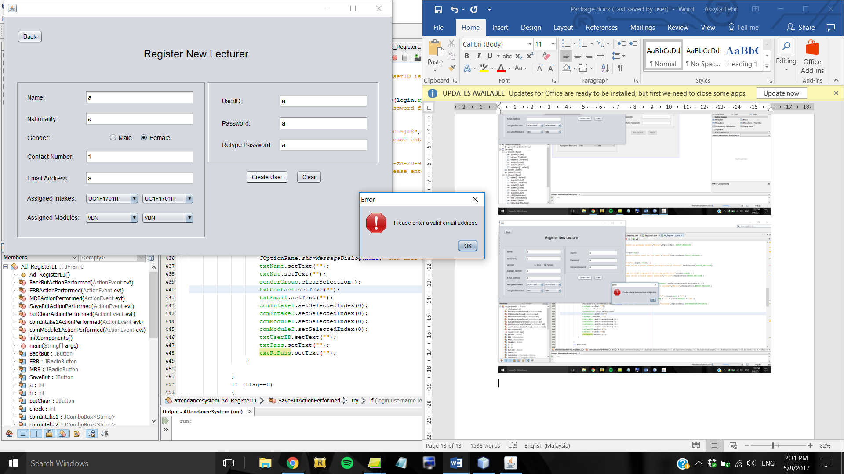

*Figure 5.4.5: Error message if wrong data type in the email address field*

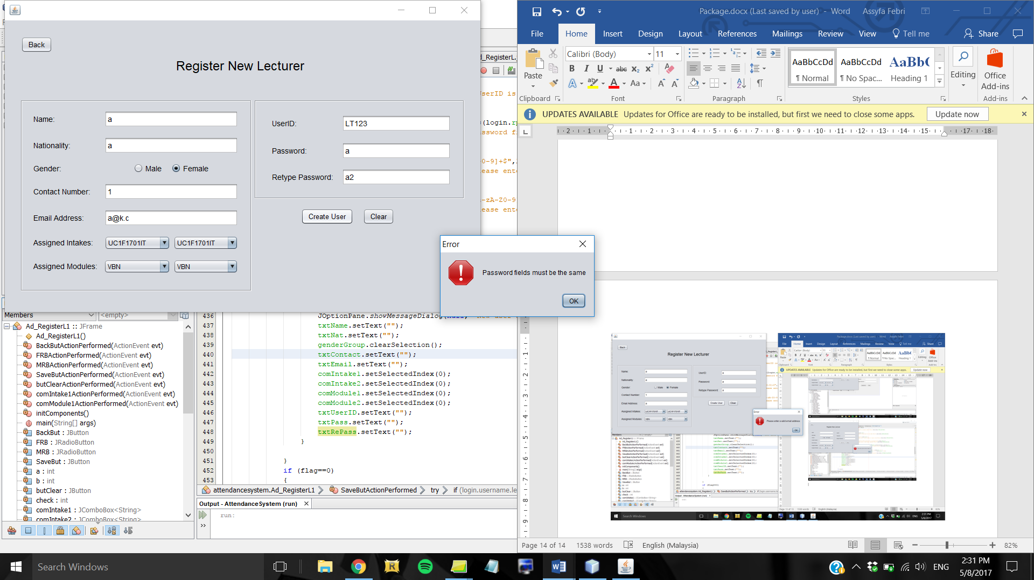

*Figure 5.4.6: Error message if password fields do not match*

Figure 5.4.1 shows the form that is displayed when Admin click the Register button for lecturer. To register a new user, all fields must be filled in. There is also regex pattern validation in the contact number field and email address field, therefore the format has to match the defined pattern, otherwise an error message will show up. Each lecturer must be assigned 2 intakes and 2 modules which can be picked from the combo box. If the 2 intakes that were picked are the same, an error message will prompt the user that the 2 intakes have to be different from one another. Furthermore, when assigning user ID and password, Admin has to retype the password again to confirm, and an error message will emerge if the password fields do not match. Once every criteria is satisfied, the system will create the new user and add the details to the appropriate file and a JOptionPane will show up to indicate that use has been successfully created. The student registration form is similar to this but without the module field.

## 5.5 View Records Form

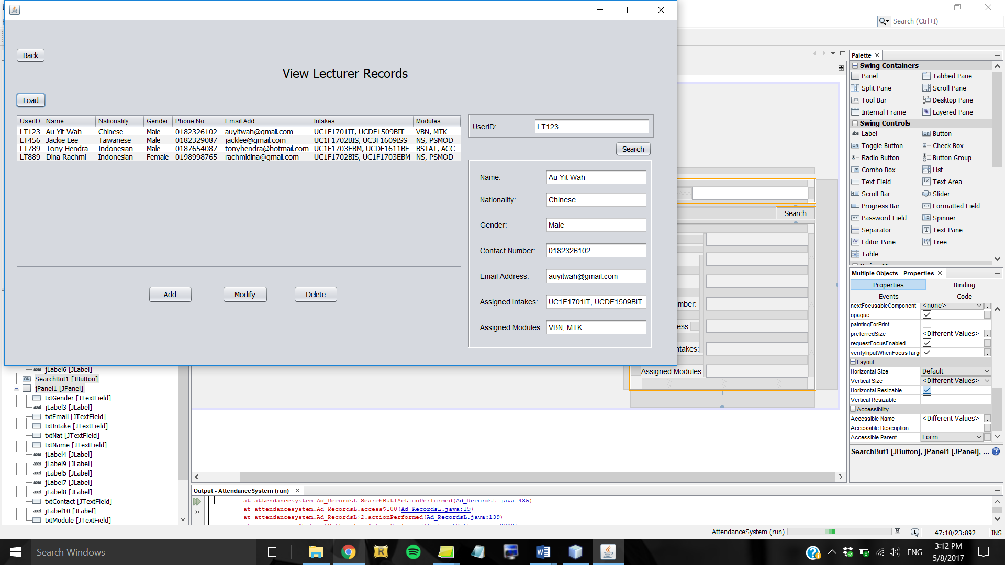

This form shows lecturer records for Admin to view. Admin has to click the Load button to get the data displayed in the JTable. Admin can also search for a particular lecturer by entering their user ID in the search bar and clicking the Search button. The system will search the text file to find the record that matches that user ID and display the results in the corresponding text fields which are non-editable. There are also buttons below the table that take Admin to appropriate forms for them to register new user, modify their details, or delete user. The form for viewing student records also looks similar to this.

## 5.6 Edit Details Form

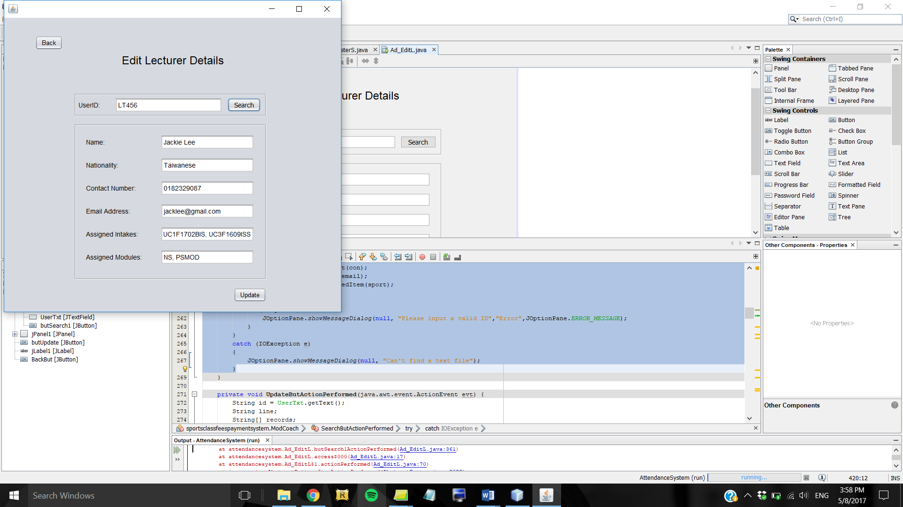

*Figure 5.6.1: Edit Lecturer Details form*

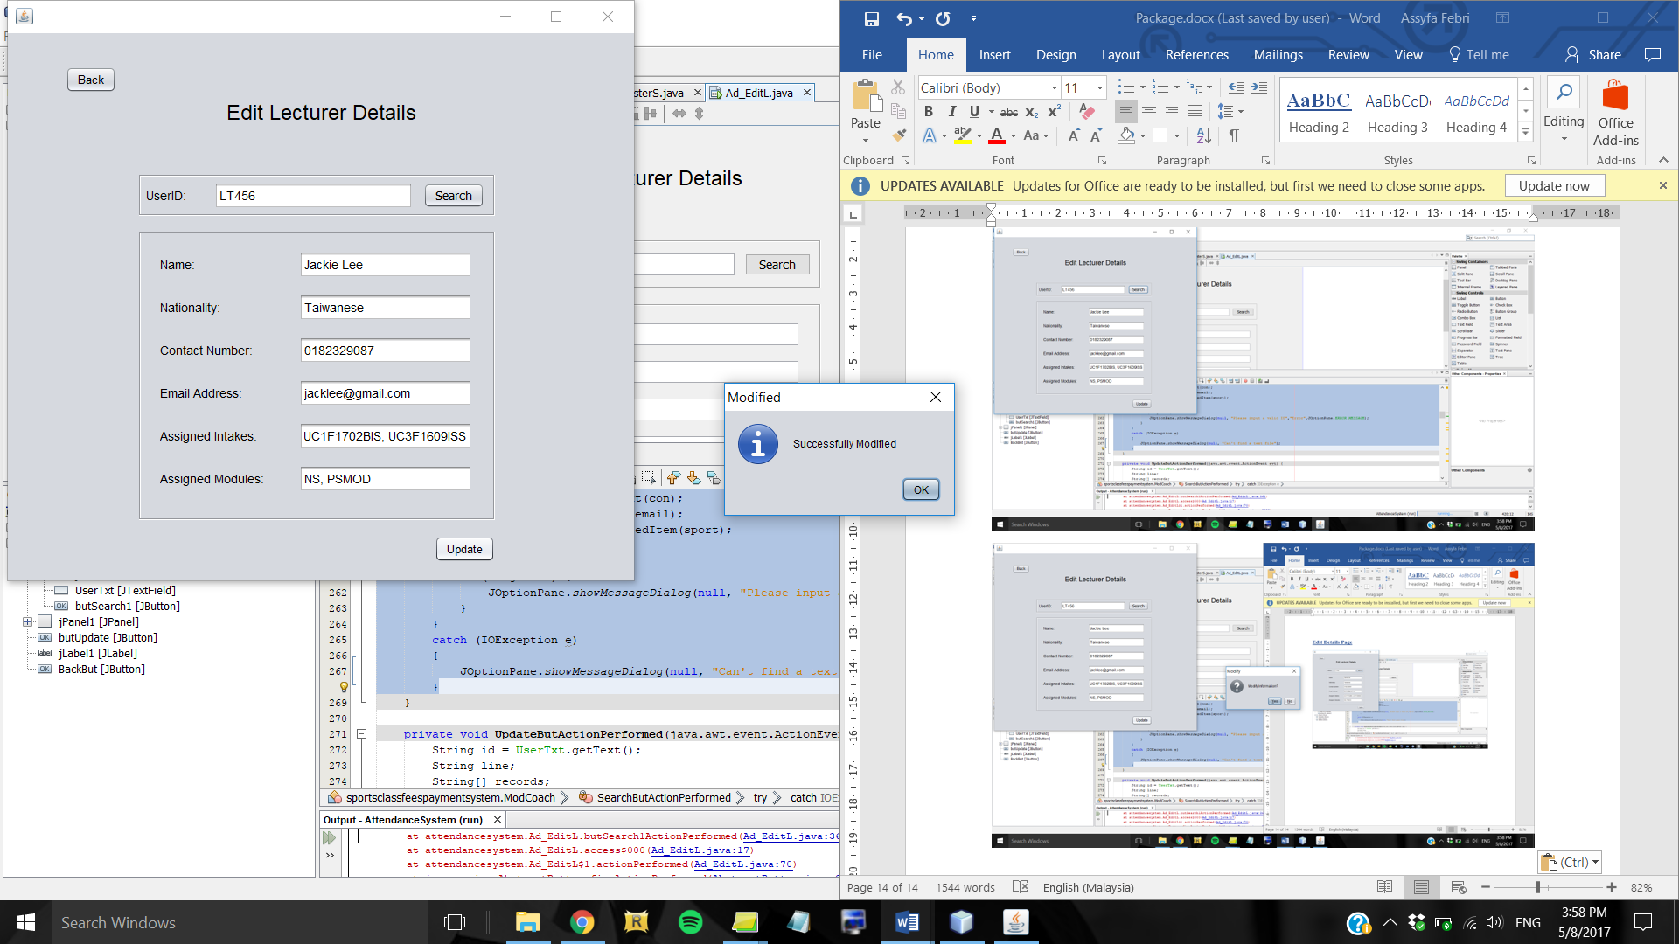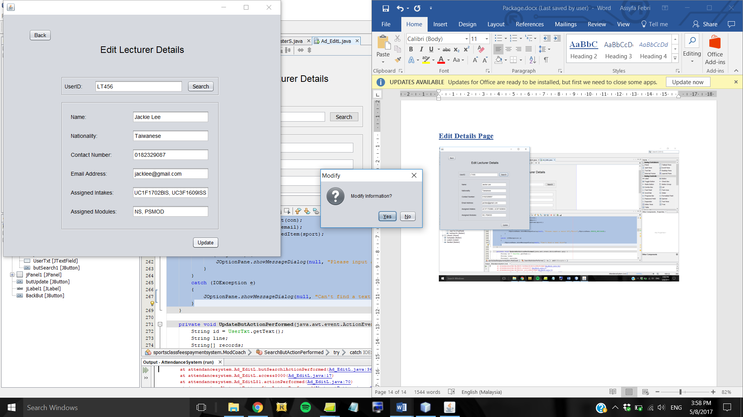

*Figure 5.6.3: Success dialog box*

*Figure 5.6.2: Confirmation pop-up before updating the data*

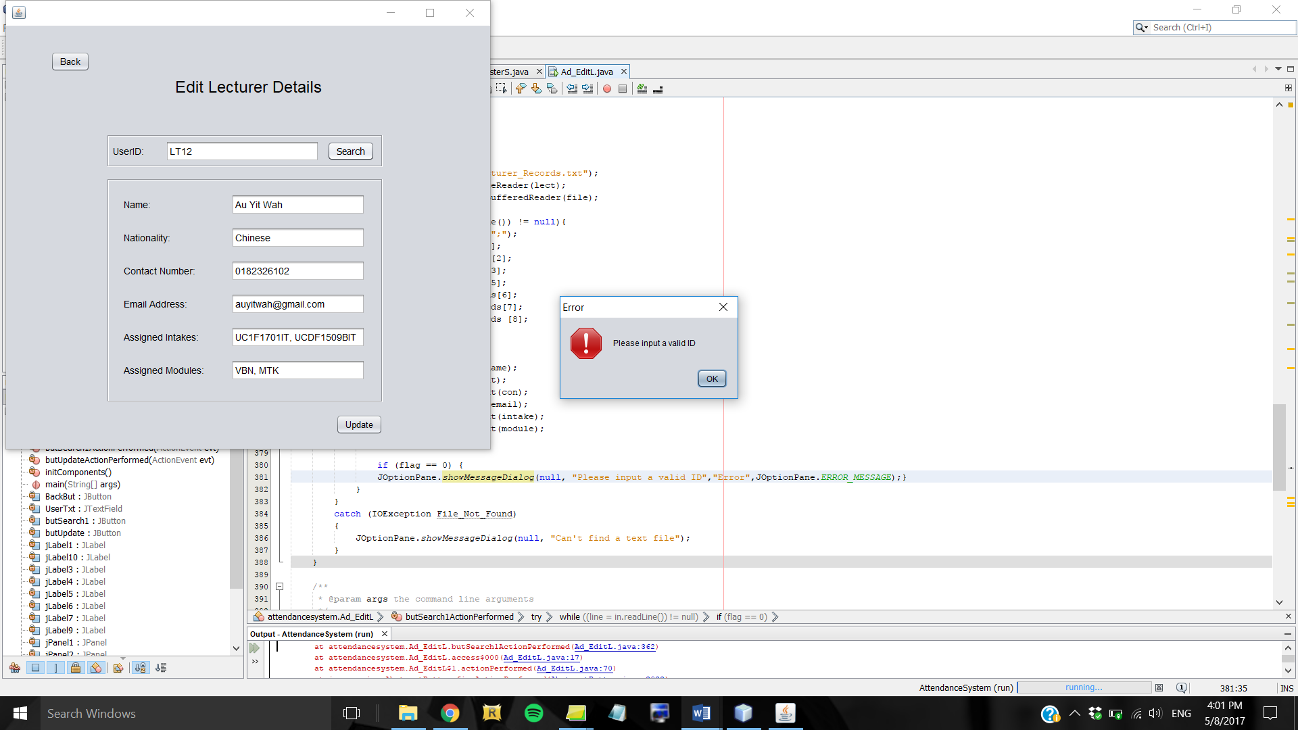

*Figure 5.6.4: Error message if the userID entered is invalid*

For modifying details of lecturer, first Admin has to search for the lecturer by entering their user ID in the search bar and clicking the Search button. If the user ID does not exist, an error message will appear. Once the record is found, the data will be displayed in the corresponding text fields which are editable. There is regex pattern validation in the contact number and email address fields therefore Admin has to enter details in the correct format, otherwise an error message will show up like in Figures 5.4.4 and 5.4.5. Once done, Admin can click the Update button which will prompt a JOptionPane dialog asking for confirmation. If user clicks Yes, the system will update the text file with new details and a dialog box will show up to indicate that the record has been successfully modified. The same concept applies to the form for editing details of students.

## 5.7 Delete User Form

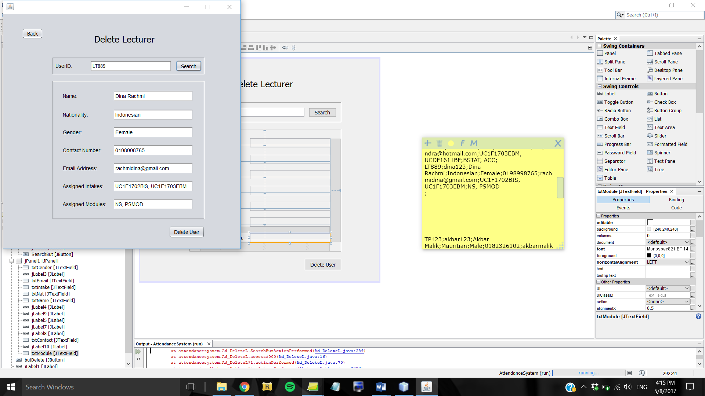

*Figure 5.7.1: Delete Lecturer form*

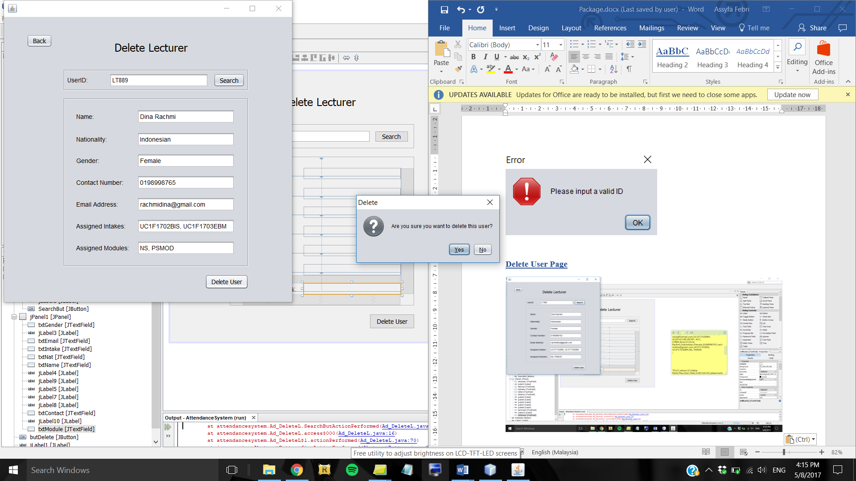

*Figure 5.7.2: Confirmation pop-up before deleting user*

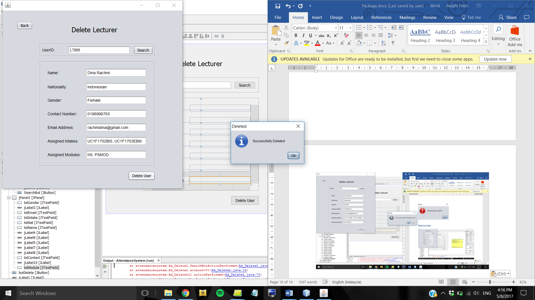

*Figure 5.7.3: Dialog box to indicate success*

The Delete Lecturer form is similar to the Edit Details form, but the text fields are non-editable. Once user has searched the account and the details are shown, user can click the Delete User button and a confirmation pop-up will appear. If user clicks the Yes option, the system will delete the record of that user and prompt a dialog box to indicate that the user has been successfully deleted. The same concept applies to the Delete Student form.

## 5.8 Inbox Form

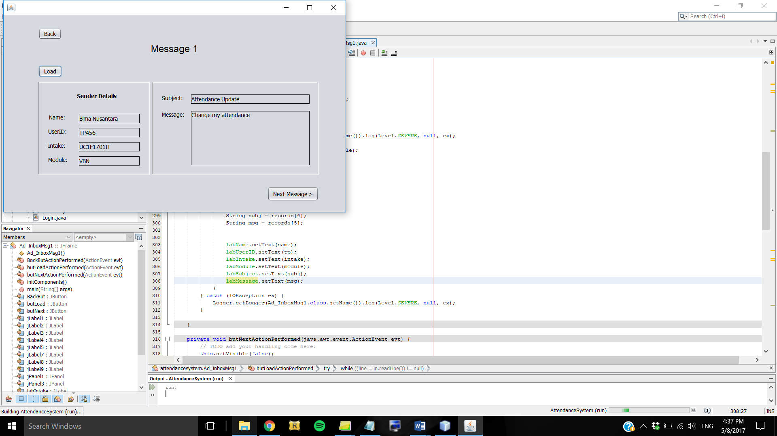

*Figure 5.8.1: Inbox form for Admin to view messages sent by students*

Clicking the Inbox button in the main menu form will lead to this form. User has to click the Load button for the details of the message to be shown in the appropriate labels. Admin can click the Next Message button to view the next message and do the same procedure.

## 5.9 View Intakewise Students Form

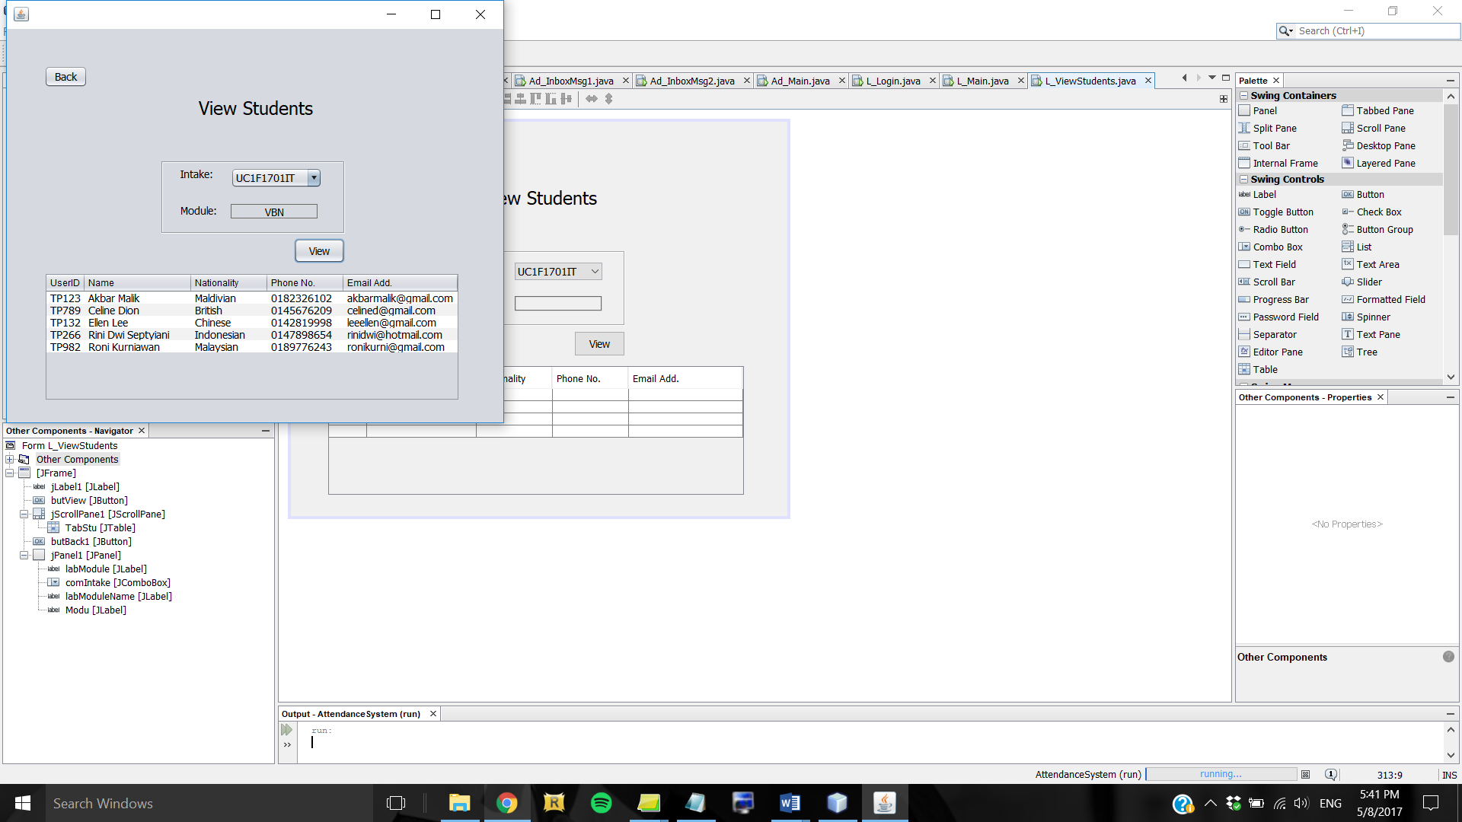

*Figure 5.9.1: View Students form for lecturer*

This is the form which shows up when Lecturer clicks the View Students button in their main menu, which allows Lecturer to view intakewise students that are assigned to them.. First, Lecturer has to choose an intake from the combo box, and the value of the module field will automatically show depending on the intake chosen. By clicking the View button, the JTable will show up containing records of students of that intake.

## 5.10 Contact Admin Form

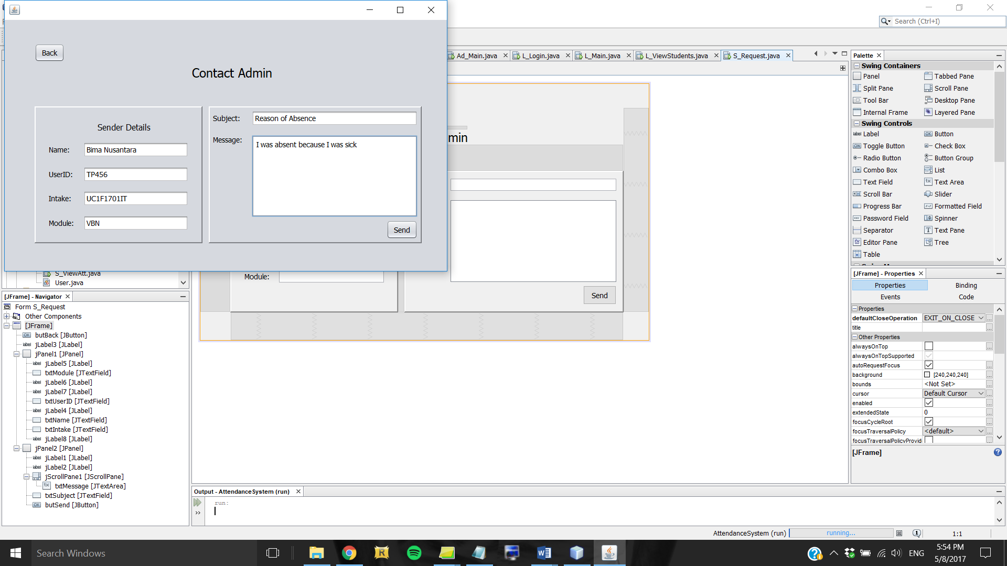

*Figure 5.10.1: Contact Admin form for students*

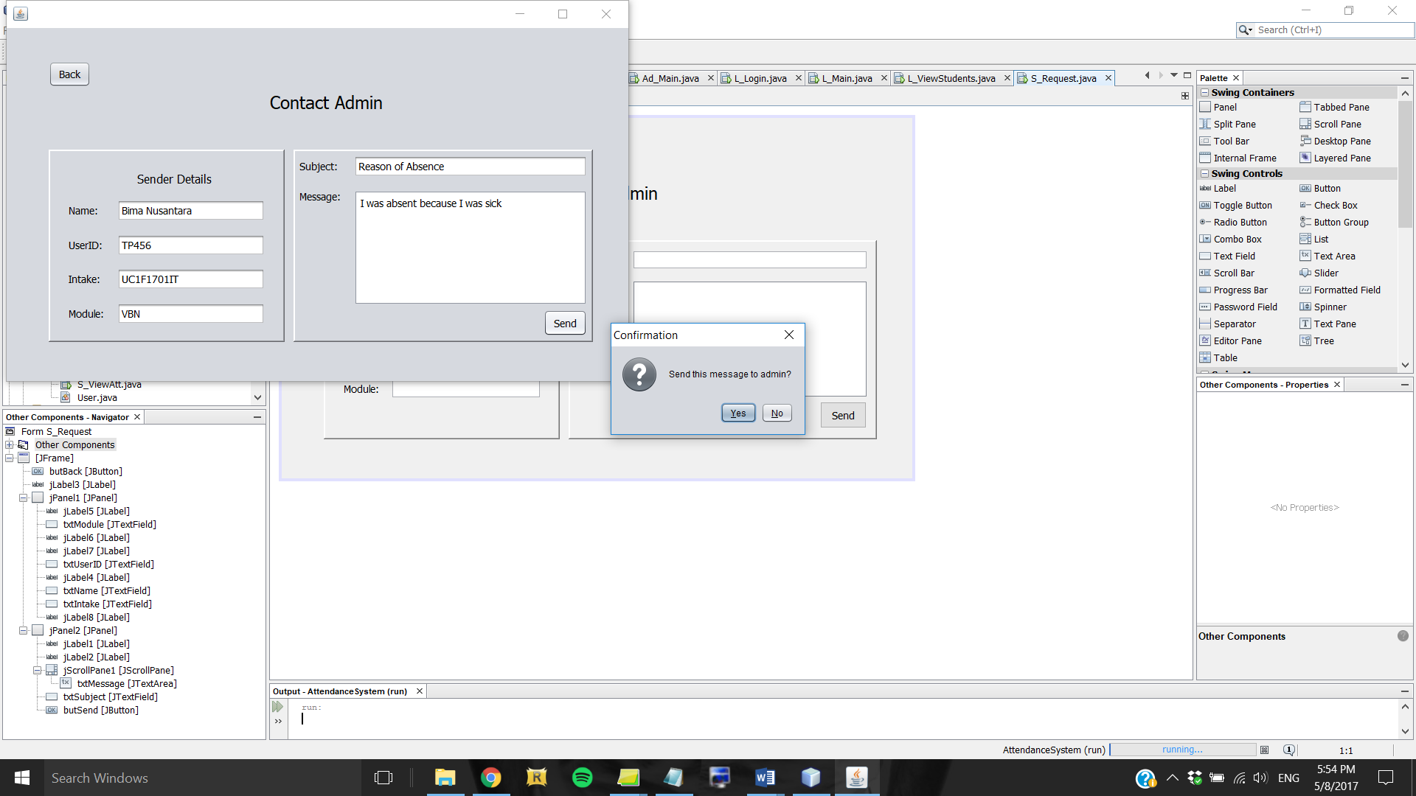

*Figure 5.10.2: Confirmation pop-up before sending message to Admin*

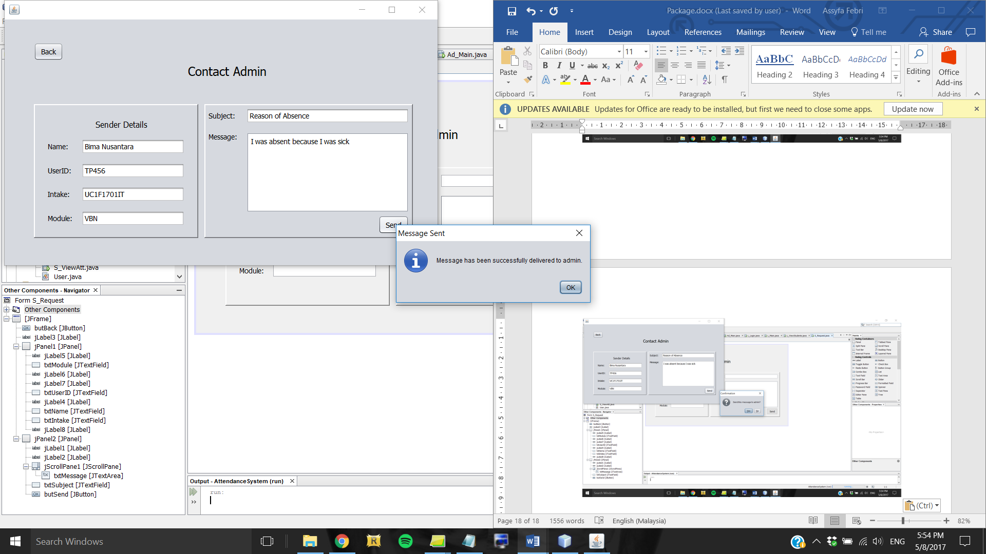

*Figure 5.10.3: Dialog box to indicate success*

Students can send message to Admin regarding their attendance update by using this form which appears when Student clicks the Contact Admin button in their main menu. Students should enter their details along with the subject of the message and the message content itself. Once done, they can click the Send button which will prompt a confirmation dialog box. If Student clicks the Yes option, the system will write the message to the appropriate file whose content will be read and displayed to Admin’s inbox. A JOptionPane will also show up to indicate that the message has been successfully delivered to Admin.

## 5.11 Mark Attendance

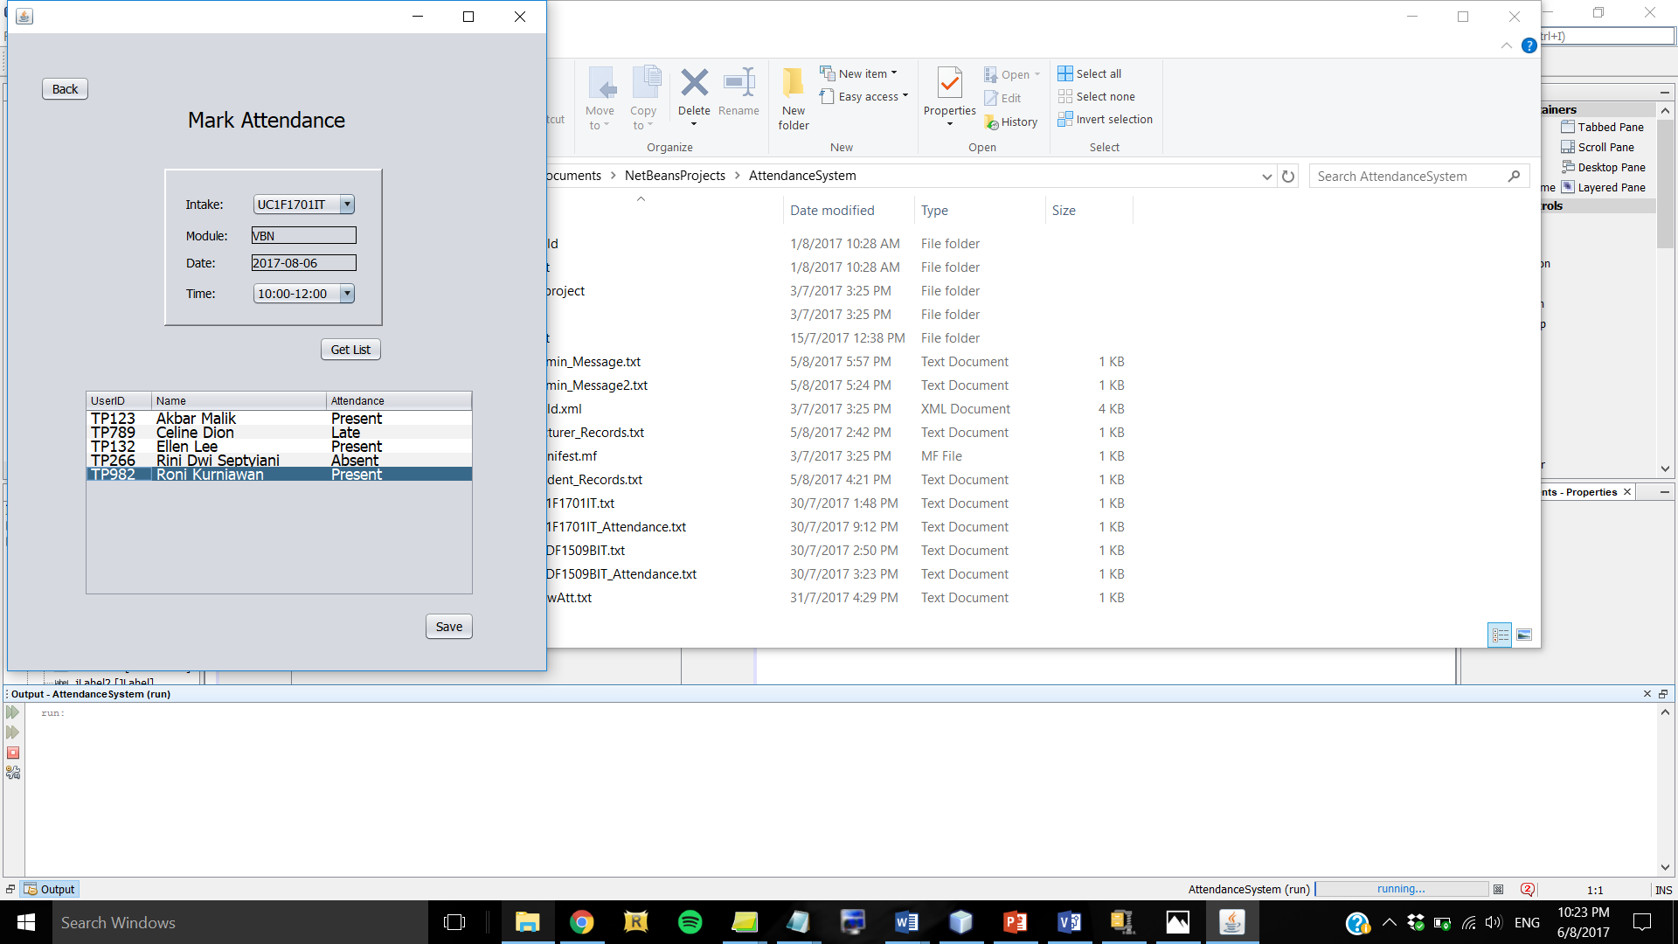

*Figure 5.11.1: Mark Attendance form for lecturer*

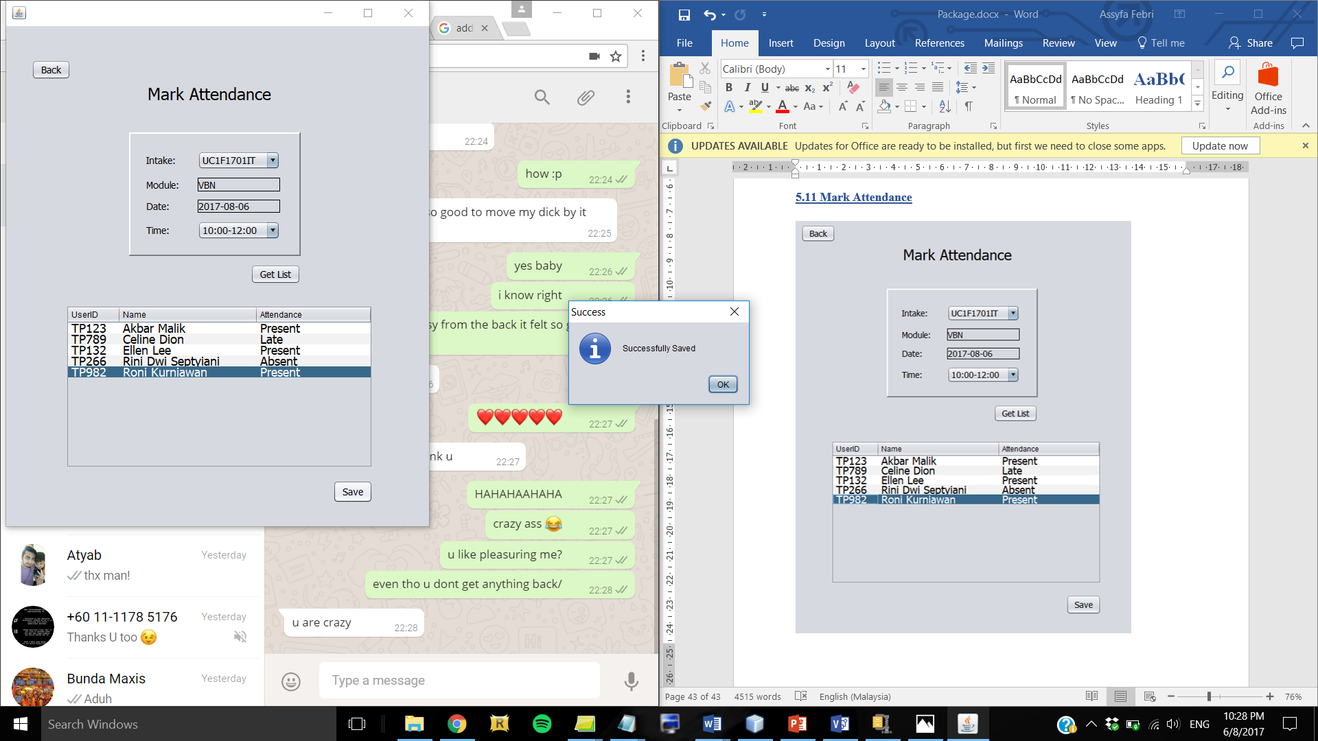

*Figure 5.11.2: Dialog box to indicate attendance has been successfully saved*

This is the Mark Attendance form to be used by Lecturer. Towards the end of each class, Lecturer will enter the class details into the system, then click the “Get List” button which will display the list of students for that class in the table. Lecturer then marks the attendance of students with PRESENT, LATE, or ABSENT and saves it. The system will save the attendance record into a specific file only for that class, this file will be used for Modify Attendance form later. If the attendance is saved successfully, a dialog box will show up to indicate success.

## 5.12 Modify Attendance

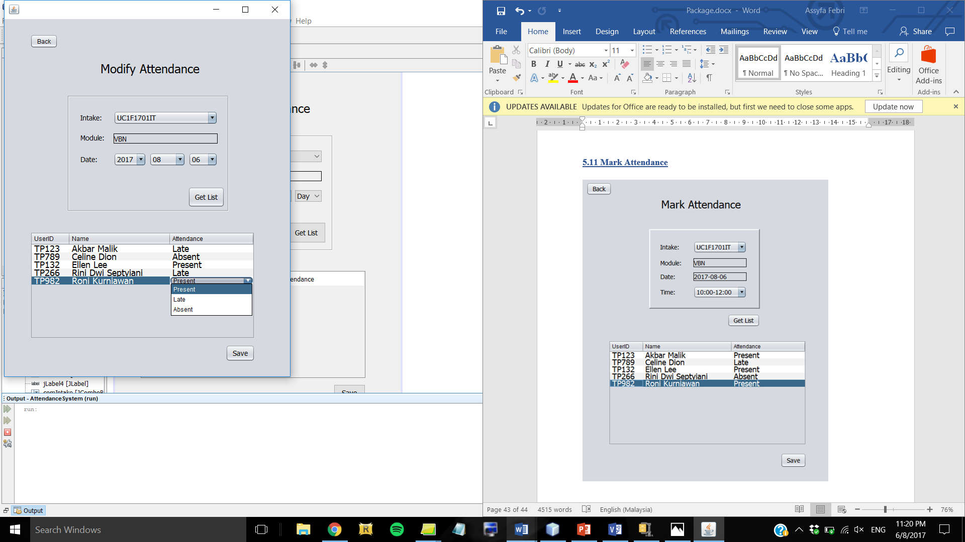

*Figure 5.12.1: Modify Attendance form for lecturer*

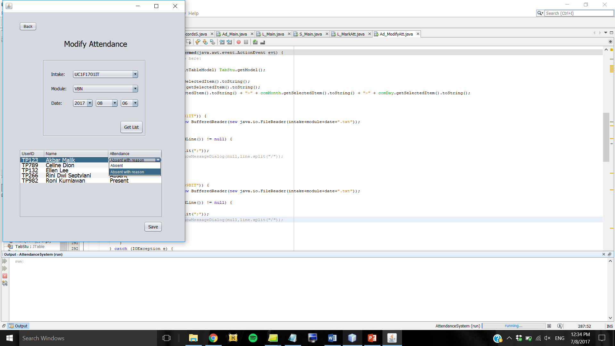

*Figure 5.12.1: Modify Attendance form for Admin*

Both Lecturer and Admin can modify the attendance of students. First, they have to enter the class details such as the intake code and the date. The module is set automatically based on the intake chosen for the Lecturer’s form, and lecturer has only 2 intake options in the combo box. But Admin has more intake options and module options. If the class exists, the list of students for the class is displayed in the table, Lecturer can modify the attendance by changing it to PRESENT, LATE, or ABSENT. But Admin can only change the ABSENT attendance to ABSENT WITH REASON. Once done, the user can save the attendance by clicking the “Save” button which will update the text file of that class.

# 6.0 Conclusion

In conclusion, this Attendance Management System has fulfilled all the functional requirements as described by users. Lecturers of XYZ University are able to mark and modify attendance for each class that they are assigned to, and view intakewise student records to get their contact details in case the lecturer needs to set up a meeting with the student to discuss matters. Meanwhile, students use this system to view their attendance summary and send message to admin to give reason for their absenteeism. Admin can search, register, edit, and delete users as well as modify attendance as per student’s request which they receive in their inbox.

However, this system reads from and saves data to text files which is inefficient and not secure. This may be improved in the future by using MySQL database to save the data which is a more organised way as well as more efficient and secure.

# 7.0 References

Brendel, W., 2009. *What is the purpose of defining a package in a Java file? - Stack Overflow.* [Online]   
Available at: https://stackoverflow.com/questions/1088509/what-is-the-purpose-of-defining-a-package-in-a-java-file  
[Accessed 4 August 2017].

Friesen, J., 2015. *Java 101: Classes and objects in Java | JavaWorld.* [Online]   
Available at: http://www.javaworld.com/article/2979739/learn-java/java-101-classes-and-objects-in-java.html  
[Accessed 4 August 2017].

Guru99, 2017. *How to use Java BufferedReader.* [Online]   
Available at: https://www.guru99.com/buffered-reader-in-java.html  
[Accessed 4 August 2017].

java2s.com, 2017. *SimpleDateFormat : Date Format << Date Format << Java Tutorial.* [Online]   
Available at: http://www.java2s.com/Tutorial/Java/0040__Data-Type/SimpleDateFormat.htm  
[Accessed 7 August 2017].

javatpoint, 2017. *Constructor in Java - Javatpoint.* [Online]   
Available at: https://www.javatpoint.com/constructor  
[Accessed 4 August 2017].

javatpoint, 2017. *Encapsulation in Java - Javatpoint.* [Online]   
Available at: https://www.javatpoint.com/encapsulation  
[Accessed 4 August 2017].

javatpoint, 2017. *Java Regex | Regular Expression - javatpoint.* [Online]   
Available at: https://www.javatpoint.com/java-regex  
[Accessed 5 August 2017].

javatpoint, 2017. *Object in Java | Class in Java - javatpoint.* [Online]   
Available at: https://www.javatpoint.com/object-and-class-in-java  
[Accessed 4 August 2017].

Jenkov, J., 2015. *Java IO: FileWriter.* [Online]   
Available at: http://tutorials.jenkov.com/java-io/filewriter.html  
[Accessed 4 August 2017].

Oracle, 2015. *Creating Objects (The Java Tutorials > Learning the Java Language > Classes and Objects).* [Online]   
Available at: https://docs.oracle.com/javase/tutorial/java/javaOO/objectcreation.html  
[Accessed 4 August 2017].

Oracle, 2015. *How to Use Password Fields (The Java Tutorials > Creating a GUI With JFC/Swing > Using Swing Components).* [Online]   
Available at: https://docs.oracle.com/javase/tutorial/uiswing/components/passwordfield.html  
[Accessed 5 August 2017].

Oracle, 2015. *The try Block (The Java Tutorials > Essential Classes > Exceptions).* [Online]   
Available at: https://docs.oracle.com/javase/tutorial/essential/exceptions/try.html  
[Accessed 4 August 2017].

Oracle, 2015. *What is a Package? (The Java Tutorials > Learning the Java Language > Object-Oriented Programming Concepts).* [Online]   
Available at: https://docs.oracle.com/javase/tutorial/java/concepts/package.html  
[Accessed 4 August 2017].

Singh, C., 2017. *How to write to file in Java using BufferedWriter.* [Online]   
Available at: http://beginnersbook.com/2014/01/how-to-write-to-file-in-java-using-bufferedwriter/  
[Accessed 4 August 2017].

Singh, C., 2017. *Try Catch in Java - Exception Handling.* [Online]   
Available at: http://beginnersbook.com/2013/04/try-catch-in-java/  
[Accessed 4 August 2017].

Swartz, F., 2017. *Java: Packages and Import.* [Online]   
Available at: http://www.fredosaurus.com/notes-java/language/10basics/import.html  
[Accessed 4 August 2017].

tutorialspoint, 2017. *Java Encapsulation.* [Online]   
Available at: https://www.tutorialspoint.com/java/java_encapsulation.htm  
[Accessed 4 August 2017].

tutorialspoint, 2017. *Java Inheritance.* [Online]   
Available at: https://www.tutorialspoint.com/java/java_inheritance.htm  
[Accessed 4 August 2017].

tutorialspoint, 2017. *Java Packages.* [Online]   
Available at: https://www.tutorialspoint.com/java/java_packages.htm  
[Accessed 4 August 2017].

Wideskills, 2015. *Java Classes and Objects | Wideskills.* [Online]   
Available at: http://www.wideskills.com/java-tutorial/java-classes-and-objects  
[Accessed 4 August 2017].